Lecture 1
Introduction to SDA
Stages in Software Process
The software design process is the stage where we plan how the software system will be built.
It converts the requirements (what to build) into a structured plan (how to build it) before coding begins.
Design explains the different parts of the system and how they will work together to meet user needs.
Main Stages in the Process
Even though there are many different ways (models) to develop software, they all usually include these main stages:
- Specification – Decide and clearly define what the system should do (requirements of the software).
- Design and Implementation – Plan the structure/organization of the system and then build (code) it.
- Validation – Test the system to make sure it does what the customer actually wants.
- Evolution – Update or change the system later when the customer’s needs change.
A software process model is simply a general representation (or diagram) of these steps.
It shows the process from a certain point of view to help us understand it better.
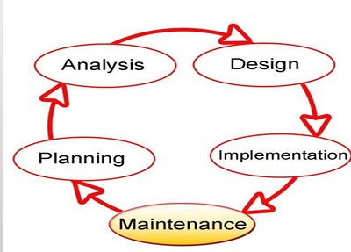
Stages in Software Process
1. Requirement Analysis
Requirement Analysis is the process of finding out what the customer or user needs and writing it down clearly.
It means deciding what services the system should provide and what limitations (rules or restrictions) it must follow.
The steps in the Requirements Engineering Process are:
- Feasibility Study – Check if building the system is possible with the available technology and if it is affordable (within budget).
- Requirements Elicitation and Analysis – Talk to stakeholders (people who will use or be affected by the system) to understand what they need or expect.
- Requirements Specification – Write down all the requirements in clear detail.
- Requirements Validation – Make sure the written requirements are correct, complete, and really match what the customer wants
Requirement Analysis – Key Challenges
While doing requirement analysis, some common problems (challenges) are:
- Stakeholder Issues – Stakeholders (users, customers, managers) may have different opinions or may not explain their needs clearly.
- Engineer/Developer Issues – Developers may misunderstand the requirements or may not have enough technical knowledge about the domain.
- Management Issues – Managers may set unrealistic deadlines, goals, or priorities that make requirement gathering harder.
- Expert Issues – Sometimes experts are not available or may give advice that is too complex for others to understand.
- Budget Issues – The cost limit may restrict what features can be included.
- Planning Issues – Poor or unclear planning can lead to missing, incomplete, or confusing requirements.
- Novelty Issue – If the project is new or unique, there may be no previous examples, making it difficult to define requirements.
Stages in Software Process
2. Design
Design means planning how the application (software) will be built. It explains the different parts of the system and how these parts will work together. The design is usually written down in the form of documents, diagrams, and text to give a clear picture before actual coding starts.
Some key points
- Design helps us connect tools and processes with our goals.
- Without design, tools and technologies are just random things with no direction.
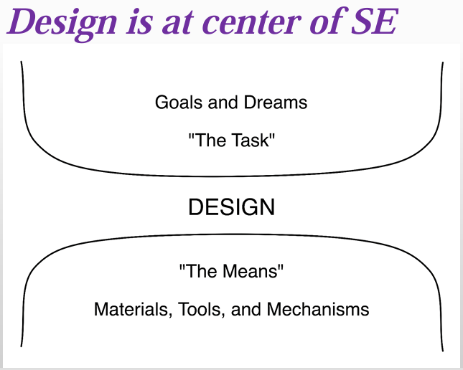
Design Continue…
- No matter how much software engineering improves, design will always be the central part.
- Design produces artifacts (documents, diagrams, models) that help in reaching the goals.
- It turns new ideas into a practical and workable form.
- It creates a balance between system complexity and project goals (by dividing system into modules or layers), so the system is both useful and manageable
Stages in Software Process
3. Implementation
Implementation means writing the actual code for the system. The code should always be written according to the design (never randomly). Before compiling (running) the program, a developer should carefully check the code by reading it line by line.
What is Author-Inspection?
Author-Inspection is when the developer who wrote the code checks it themselves. The author (programmer) carefully reviews their own code to make sure it is correct, clear, and matches the requirements, before giving it to others or running tests.
Stages in Software Process
4. Testing
Testing means giving input to the application and checking if the output matches the requirements written in the Software Requirements Specification (SRS). It helps to find defects (mistakes or errors) in the system.
Important: Testing can prove defects exist, but it can never prove that the software has no defects at all.
Types of Testing
- Black-Box Testing – Testing the system from the outside (focus only on input and output, without looking at the code).
- White-Box Testing – Testing the system from the inside (looking at the actual code, logic, and internal paths).
Verification vs Validation (V & V)
Verification = Checking the process
- Ask: Did we build the product correctly according to the design/specifications?
- Focus: Following the rules and steps properly.
- Example: Suppose you are baking a cake. Verification means checking the recipe step by step (Did I add sugar? Did I preheat the oven?).
Validation = Checking the final result
- Ask: Did we build the right product that the customer actually wants?
- Focus: Meeting the user’s needs.
- Example: After baking, validation means tasting the cake to see if it’s actually delicious and what the customer wanted.
Testing – Tips for Good Testing
- Test early and often – Start testing as soon as possible and keep testing regularly.
- Test with extreme values – Try very small and very large inputs (e.g., 0, max limit) to see how the system reacts.
- Test borderline values – Check values at the edges (just before or after the valid range).
- Example: If age input is allowed from 18–60, test with 17, 18, 60, 61.
- Test with “illegal” values – Give invalid inputs (like letters where numbers are expected) to see if the system handles errors properly.
- Vary test cases – Use different kinds of data to cover more situations.
- Don’t repeat the same test data – Unless required, avoid running the same test again and again, use new inputs to find hidden issues.
Stages in Software Process
5. Maintenance
- Maintenance means the work done on the software after it has been delivered to the customer.
- Its purpose is to keep the software useful, correct, and up to date.
Types of Maintenance
- Corrective Maintenance (Defect Removal)
- Fixing errors or bugs found after the software is delivered.
- Example: Repairing a broken login function.
- Perfective Maintenance (Enhancement)
- Adding new features or improving existing ones.
- Example: Adding a “dark mode” option to an app.
- Adaptive Maintenance
- Modifying the software so it works in a new environment (new hardware, OS, or database).
- Due to need
- Example: Updating an app to run on the latest Android/iOS version.
- Preventive Maintenance
- Making changes to avoid future problems or failures. No defect in the system but you think if some event triggered then the system can be crash or fail.
- Example: Cleaning up code or updating libraries to reduce security risks.

Design?
- Design means creating a plan for building an object or system.
- It works like a roadmap or a strategy to achieve a specific goal.
- It is about how the system functions.
- In software design, the goal is to create a model that meets all the customer’s requirements and makes implementation (coding) successful.
- Design also defines:
  - Specifications (what to build)
  - Plans and processes (how to build)
  - Costs and activities (resources needed)
  - Rules and constraints like legal, social, environmental, safety, and economic limits.
In short: Design is a detailed plan that helps turn ideas into a working system while respecting all requirements and restrictions.
Design and Requirements
- Requirements specification describes WHAT the system should do.
- Design describes HOW the system will actually work.
- It breaks the system into smaller parts (decomposition) so it is easier to understand and build.
- This division also helps to split the work among different developers in a team.
- Design also ensures non-functional requirements like good performance, easy maintenance, and reusability.
- It also considers the target technology (like databases, programming language, or platforms).
In short: Design is the step that converts “what to build” into “how to build it.”
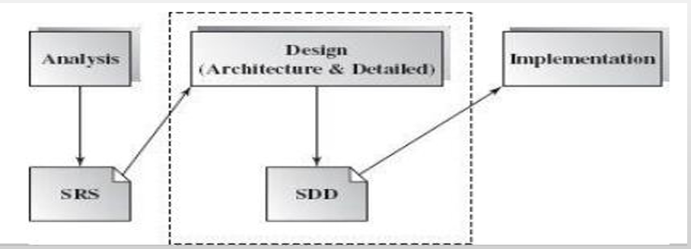
Design as Decision Making
In requirement engineering and design, a lot of decisions have to be made:
- Decisions of how to accomplish something – Example: Which algorithm or method to use.
- Decisions of how to represent something – Example: Should data be stored in a database table, a file, or a data structure.
Relation between Design and Decision Making
- Design = A collection of decisions about how the system will be built.
- Each design choice affects how well the system meets requirements.
Types of Decisions in Design
- Capturing decisions – Writing down what decisions were made and why.
- Analyzing and comparing alternatives – Looking at different options before choosing the best one.
- Managing alternatives – Keeping track of possible solutions.
- Reflecting on past decisions – Learning from previous choices to make better designs in the future.
- Creating reusable knowledge – Turning design experience into guidelines or patterns that can be reused in future projects.
In short: Design is really about making smart decisions, recording them, and reusing that knowledge to build better systems in the future.
Design – Software Architecture
Software Architecture is about the big design decisions in a project. These decisions are very important—if made wrongly, the whole project can fail.
What Software Architecture Defines
- Components of the system – The main parts or modules of the software.
- Interaction between components – How these parts share functionality and data with each other.
- Control management – How control (flow of execution) is passed from one component to another.
In short: Software architecture is the “high-level design” that shows the main building blocks of a system and how they work together.

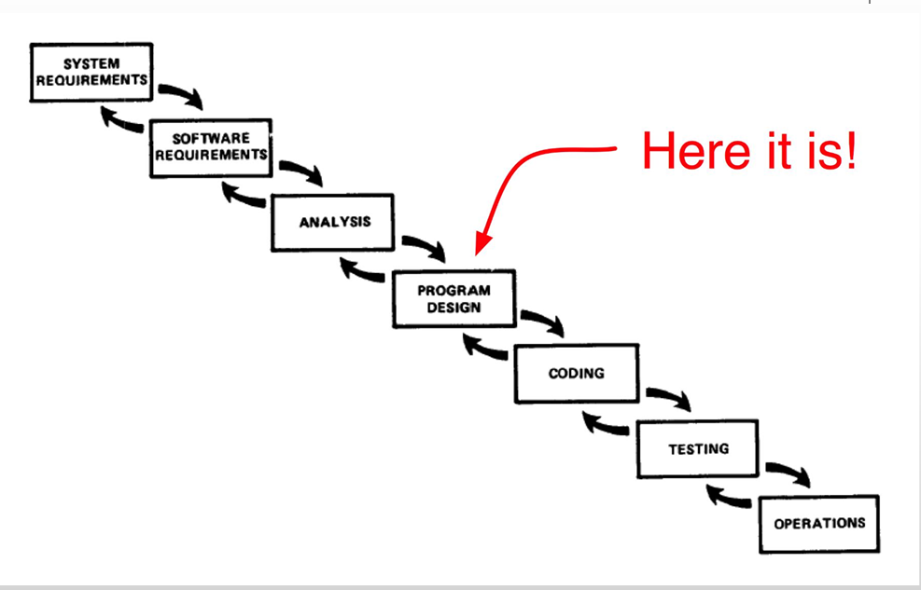
Desing Approaches
1. Top-Down Design
- Start with the big problem (whole system).
- Break it down step by step into smaller sub-problems.
- Keep dividing until each part is small enough to solve.
- Limitation: Pure top-down is not practical for very large systems because it can become too complex.
- Example: Designing a car by first planning the whole car, then dividing into engine, body, wheels, and then into smaller components.
2. Bottom-Up Design
- Start with existing small solutions (components/modules).
- Combine and adapt them to fit the larger problem.
- Builds the big system by assembling smaller, already available pieces.
- Example: Designing a car by first gathering ready-made parts (engine, tires, seats), then assembling them into the full car.
What is architecture?
Software architecture is the “high-level design” that shows the main building blocks of a system and how they work together.
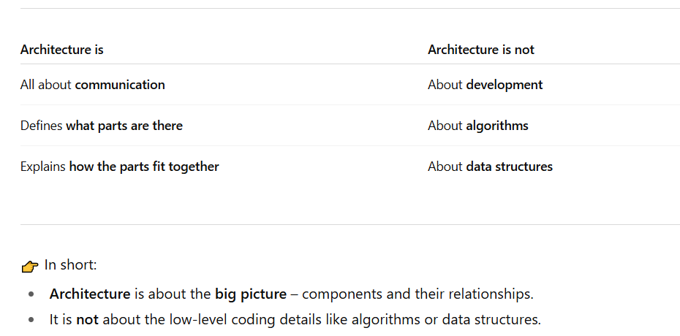
Importance of Design
As software systems keep getting bigger, more complex, and spread out, it becomes very important to design them properly.
- Every software, no matter what it is made for, should have a clear architecture design that guides how it is built and developed.
- The success of a software product mostly depends on how good its architecture design is.
- Architecture is like a small and clear model that shows how the system is organized and how different parts work together.
- These architecture designs also help in communication between all the people (stakeholders) who are involved in making the system.
Q: Where most of the work is done in software?
Ans: Most of the work is done in the maintenance phase. But for the maintenance system understanding is most important so in order to understand the system design plays an important role.
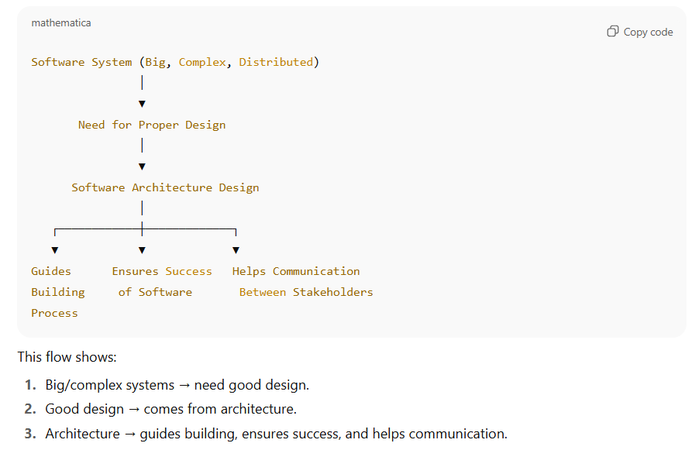
Importance of Design
- If the design is poor, the software may not meet the required needs.
- It may not adjust easily when new requirements or changes are needed in the future.
- It may not be reusable, meaning the code can’t be used again in other projects.
- It may show unexpected errors or slow performance.
- Without good planning in the architecture stage, making the software can take too much time and cost more money.
Q: How to Ensure Reusability?
- Modular Design
- Follow Coding Standards
Level of Design
Architectural Design (High-Level Design)
Architecture shows the overall structure of the system – the main modules and how they connect to each other.
It is a design that focuses on the main use-cases (important features the system must handle).
It also takes care of non-functional requirements like performance, security, and reliability.
Architectural design is usually hard to change later (like building), so it must be planned carefully.
A high-level design document normally has an architecture diagram that shows:
- The main components,
- How they interact (interfaces),
- The networks or connections needed.
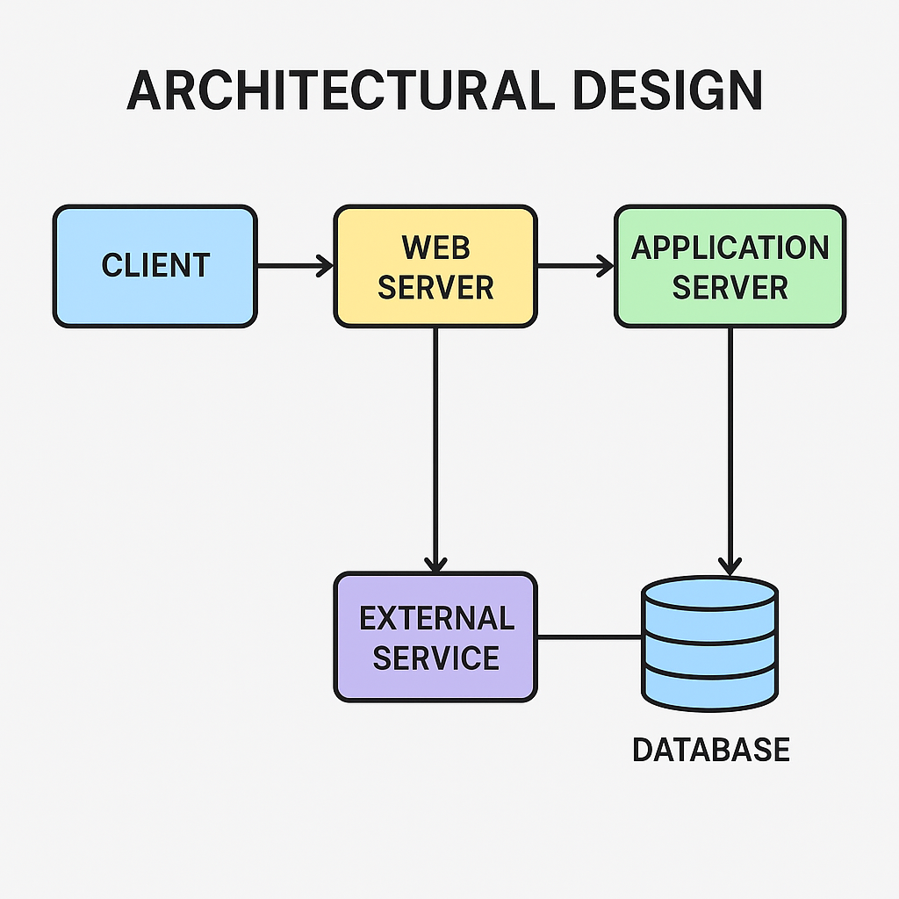
Detailed Design (Low-Level Design)
- Shows the inside structure of each main module.
- Considers the programming language to be used (Java, Python, etc.).
- Provides enough detail so developers can directly write the code.
Example
- High-Level Design: "User Module"
- Low-Level Design: "User class with login (), logout (), update-Profile () methods, and a user’s database table."

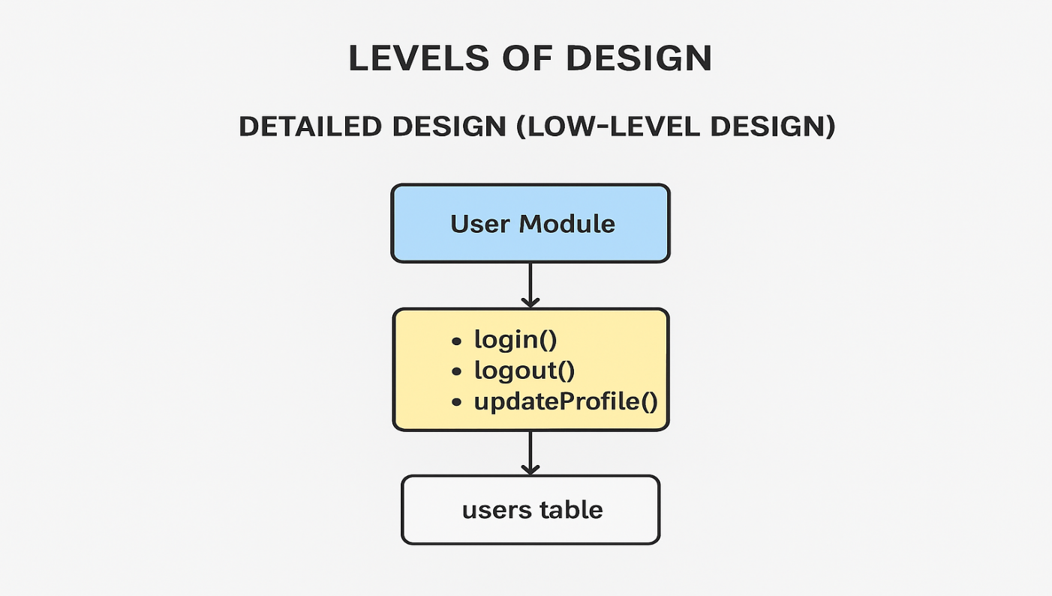
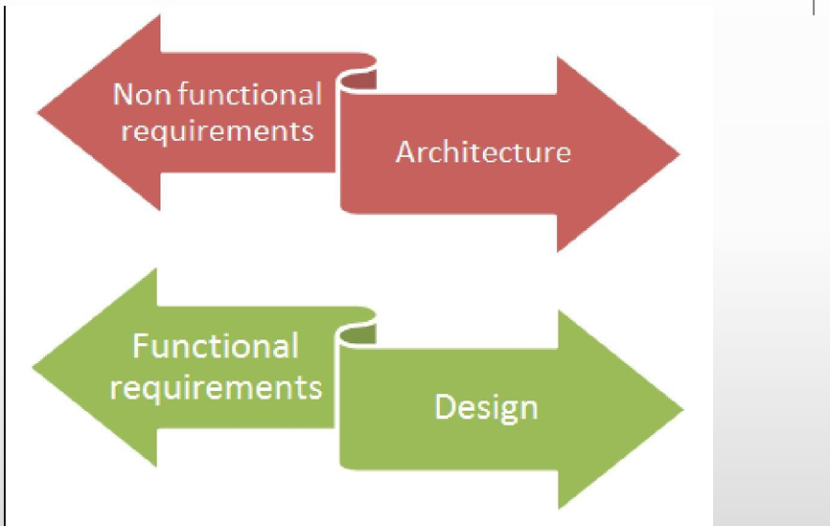

Scenario
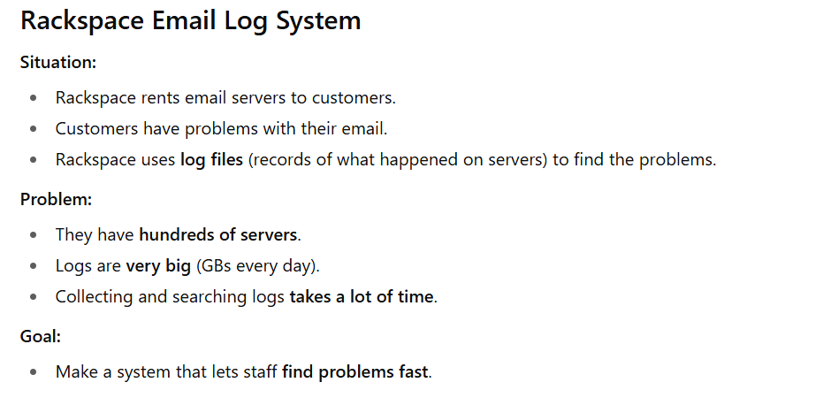
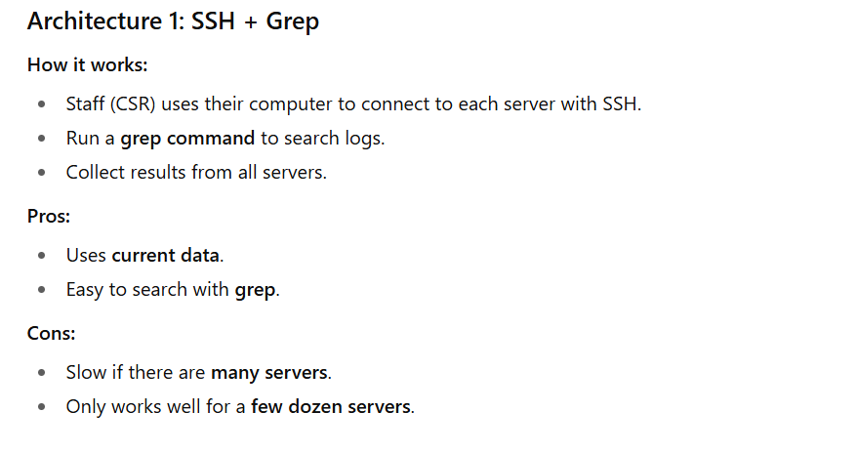

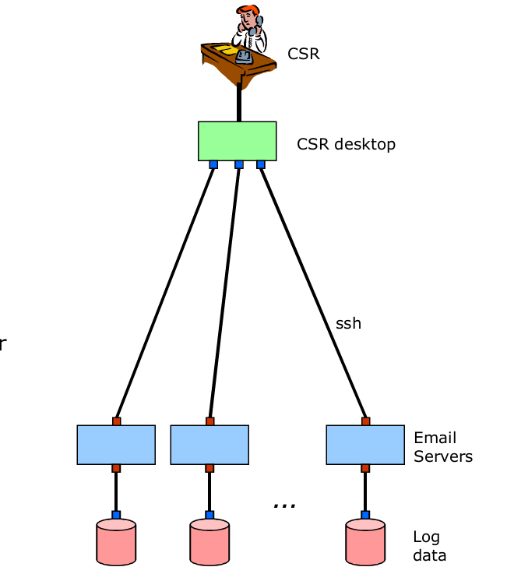
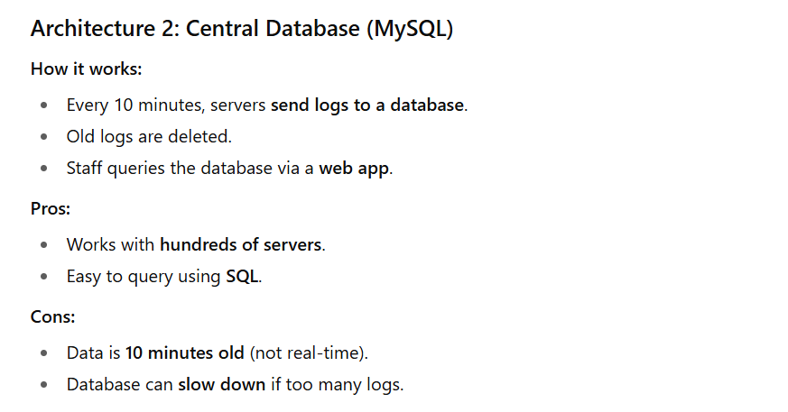
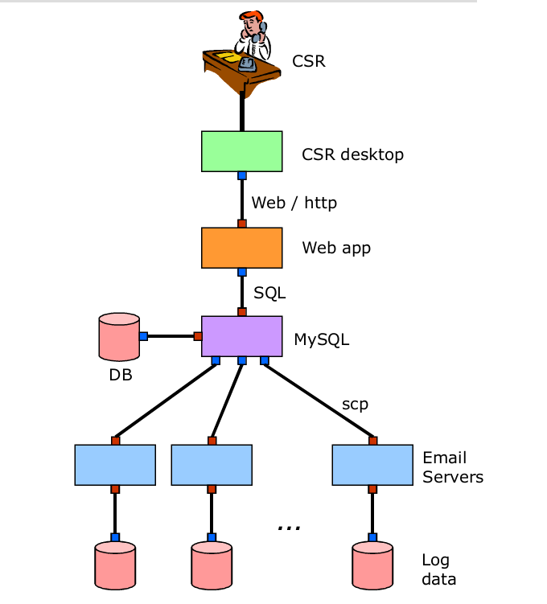
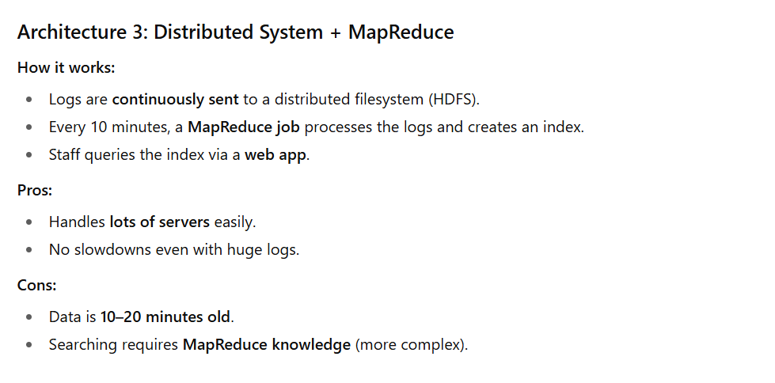
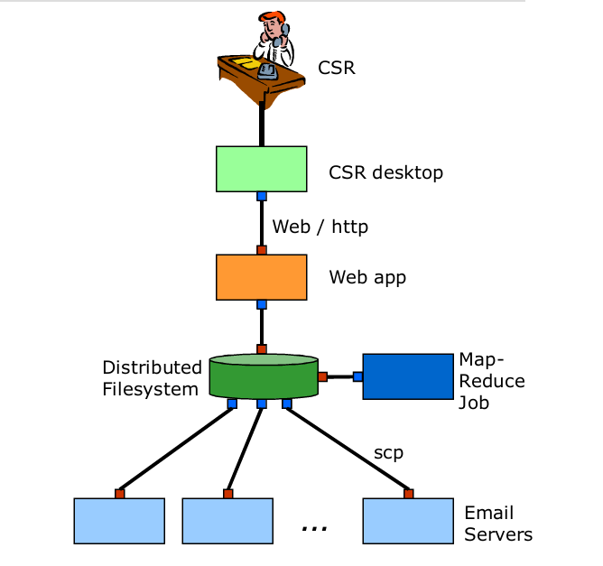
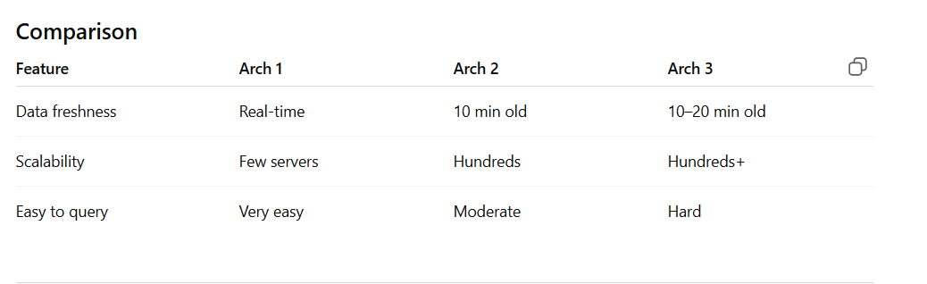
Lecture 2
Architecture Design Decisions
Basic Architectural Representations
The most common way to explain software architecture is by using simple and informal block diagrams. These diagrams show the main parts (entities) and how they are connected (relationships).
However, people often criticize these diagrams because they are too simple. People say these diagrams are not good enough because they only show boxes and arrows without much explanation.
- They don’t explain the exact meaning of the connections.
The arrows or lines just show that things are connected, but they don’t tell us how they are connected or what kind of connection it is (for example: “sending data,” “controlling,” “storing,” etc.).
- They don’t explain the types of relationships.
We can’t tell whether the parts are “dependent,” “communicating,” “sharing data,” or something else.
- They don’t explain the clear details (properties) of each part of the architecture.
The diagram doesn’t show the important features of each block, like what it does, what inputs it takes, or what outputs it gives.
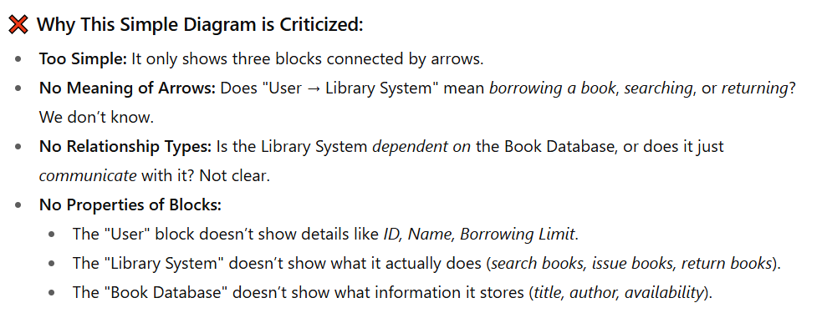
Better Representation
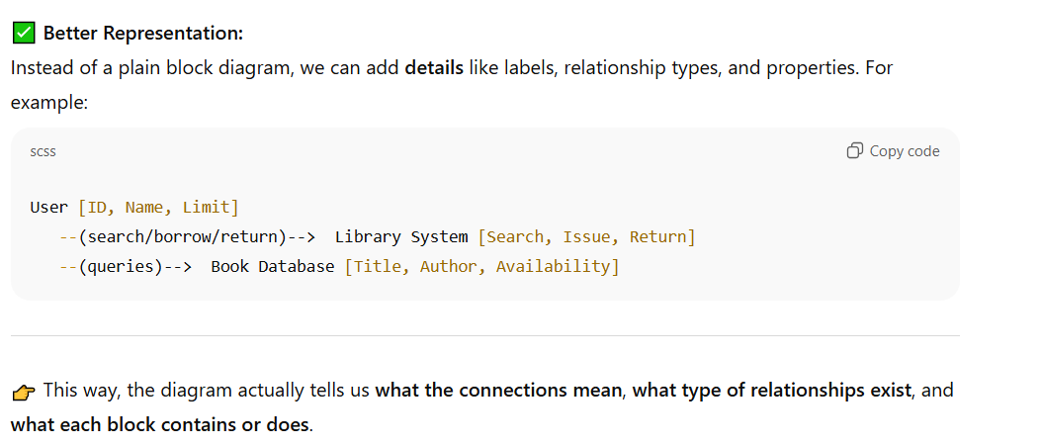
Box and Line Diagrams
These diagrams show the general shape or outline of an architecture design.
They are very high-level and abstract – they don’t explain what kind of relationships exist between the parts, or the clear details (visible properties) of the sub-systems.
Still, they are useful for talking with stakeholders (people interested in the project) and for planning the project.

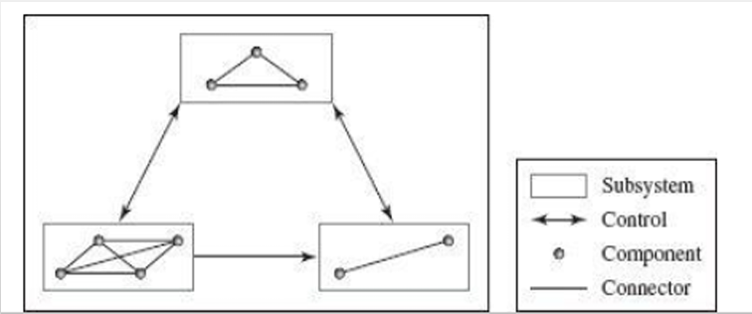
Continue…
- The parts of a system can be divided based on what they do (functionality), where they are placed (location), and how they look or work when the program is running (runtime images).
- The structure of the system (topology) shows how these parts are arranged. This can be in different forms like layered, flat, star-shaped, centralized, or spread out (distributed).
How System made up off?
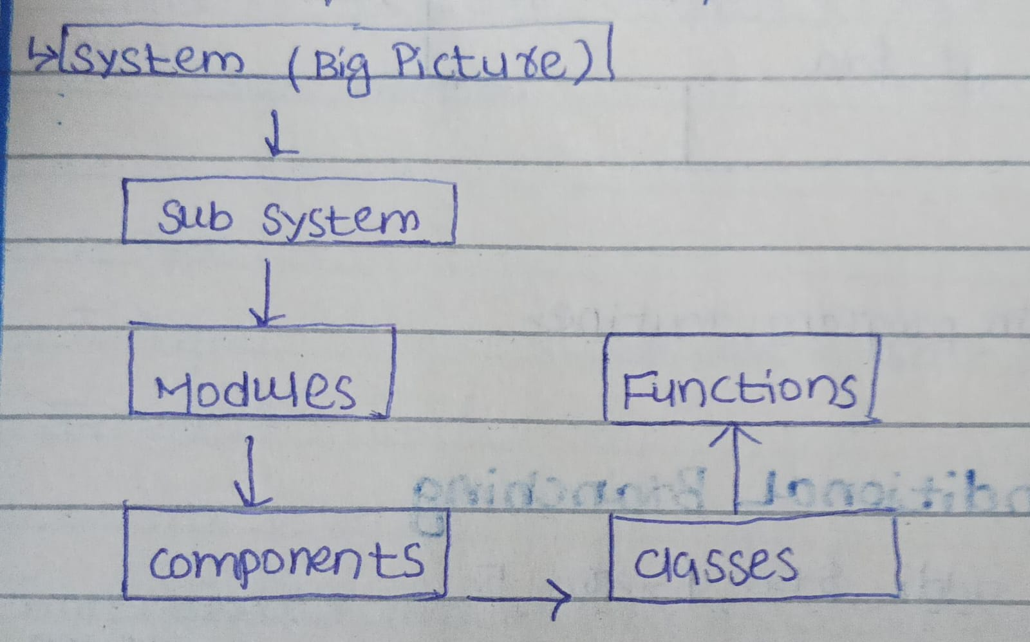
Use of Architectural Models
A full software architecture description should not only explain the parts (elements) and how they connect, but also the rules (constraints) and how the system will behave when running. This helps developers clearly understand what to build and how to build it.
The main tasks of a software architect are:
- Divide the system into smaller parts (subsystems) and explain how these parts communicate with each other.
Example: In an online shopping app, divide into User System, Oder System, and Payment System.
- Make sure each software part can be set up (configured), built (developed), delivered, installed (deployed), and even replaced later if needed.
Example: The Payment System can be updated or replaced with PayPal without changing the whole app.
- Define each part’s interface clearly so it can connect and work properly with other parts or subsystems.
Example: The Payment System provides a clear interface (like a menu) with an option called makePayment(). When the Order System needs to take money, it just calls makePayment() from the Payment System’s interface.
- Set up how different subsystems control and interact with each other, for example through data flow, control flow, or message passing.
Example: When a user places an order, data flows from User System → Order System → Payment System.
- Think about and compare different architecture styles, then choose the one that best fits the specific problem.
Example: Choose a layered architecture for an online shopping app (UI layer, business layer, database layer).
Architectural Design Decisions
Architectural design is a creative process, so the way it is done can change depending on what kind of system is being built.
Still, there are some common decisions that are part of almost every design process, and these decisions usually affect the system’s non-functional features (like performance, security, reliability, or scalability).
Some common decisions?
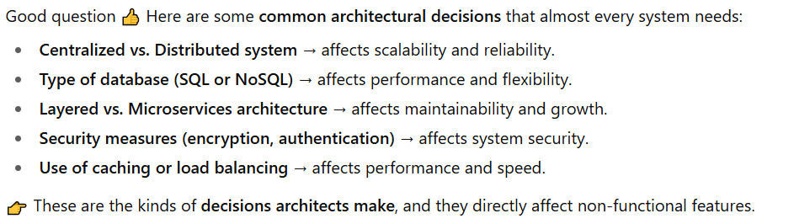
How does architecture affect the nonfunctional requirements?
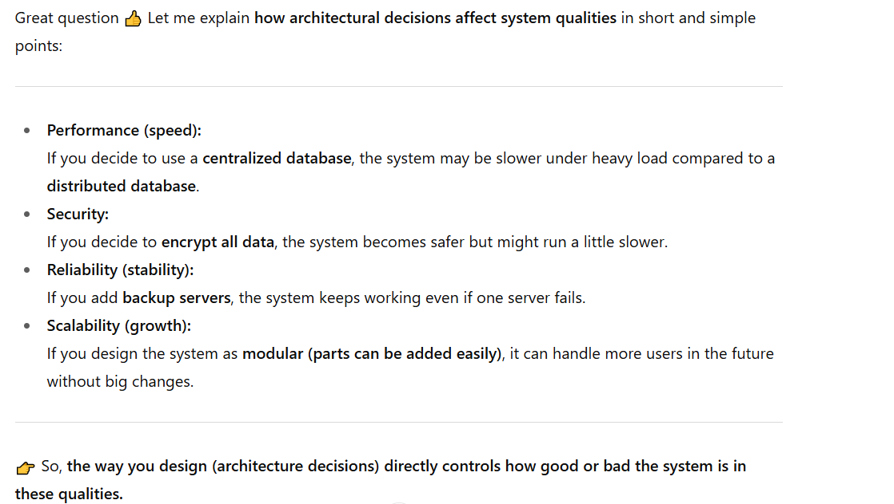
Architectural Design Decisions Continue…
Should we use a ready-made (generic) application architecture that already exists?
Example: Use a standard e-commerce architecture instead of designing from scratch.
How should the system be spread out (distributed)?
Example: Run the database on one server and the application on another for better performance.
Which architectural style or model is the best fit?
Example: Choose a client-server model for a banking system.
What method will we use to organize the system’s structure?
Example: Use a layered structure (UI layer, business layer, database layer) for an online shopping app.
How will we break the system into smaller modules or parts?
Example: Split into User Module, Order Module, and Payment Module.
What type of control strategy will manage how parts interact?
Example: Use message passing so services communicate through messages instead of direct calls.
How will we check (evaluate) if the chosen design is good enough?
Example: Test if the system can handle 10,000 users at once without crashing.
What is the best way to write down and document the architecture?
Example: Use UML diagrams and written notes so developers can easily understand the design.

Architectural Design Decisions Continue...
Architecture Reuse
Systems that belong to the same domain (area) often have similar architectures because they use the same main ideas.
A group of similar software products is made using the same basic design, and then small changes are added to match what different customers want.
Architectural Views
Each architecture model shows only one side (view) of the system.
For example, it may show how the system is divided into modules, how processes work together when running, or how parts of the system are spread across a network.
To properly design and document the system, you usually need to show multiple views of the software architecture.
Architectural Design Decisions Continue…
1+4 View Model
This model is used to describe a software system from different angles (views) so developers, users, and designers can all understand it easily.
It has 4 main views and 1 central view (the “+1”).
1. Logical View
- Shows what the system does.
- Focuses on main parts (objects or classes) of the system and their relationships.
- Used by designers and developers to understand the structure.
- Example: In a banking app, it shows objects like Customer, Account, Transaction.
2. Process View
- Shows how the system runs and how different parts communicate during execution.
- Focuses on processes, threads, and data flow at runtime.
- Helps in understanding performance and communication.
- Example: How the login process talks to the database and the user interface at the same time.
3. Development View
- Shows how the system is built by developers.
- Focuses on software modules, files, and directories.
- Useful for managing the code and teamwork.
- Example: Dividing code into folders like /frontend, /backend, /database.
4. Physical View
- Shows how the system is deployed on hardware.
- Focuses on servers, networks, and computers where the software runs.
- Used by system engineers.
- Example: Web server on one machine, database on another.
The “+1” — Scenarios or Use Case View
This “+1” part connects all the 4 views together.
It shows how the system actually works in real life — step by step.
Think of it like a story of how the user uses the system, showing how all other parts (logical, process, development, and physical) work together.

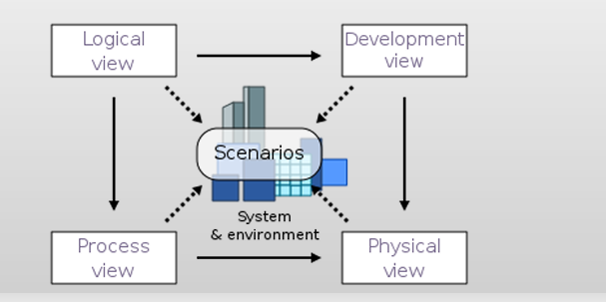
Quality Attributes and Good Design
A good software design means creating a system that works correctly, runs efficiently, is easy to maintain, and can adapt to future needs. These qualities together make the software more reliable and useful.
1. Efficiency
Efficiency means how quickly and smoothly a system responds to user actions or events.
It shows the system’s speed and performance. The total time for handling any task (event) depends on three main parts:
- Communication time: The time taken for different parts of a system to send or receive data from each other.
Example: In an online shopping app, when a user clicks “Buy Now”, the app sends data to the payment and inventory systems.
The delay in sending and receiving this information is called communication time.
- Processing overlaps: It means two or more parts of the system are working together at the same time, not one after another. This saves time and makes the system faster.
Example: In a video app, while one part is playing the current video, another part is downloading the next portion.
Both tasks happen together, not one after finishing the other — that’s called processing overlap.
- Computation time: The time each part takes to finish its own work.
Example: A bank server calculating your account balance.
A good design reduces unnecessary delays and helps the system respond faster.
2. Correctness
Correctness means the system performs exactly what the user requirements say.
If the design does not match the given requirements, the final software will also be incorrect.
So, correctness begins with a design that fully follows the user’s needs and system goals.
3. Reliability
Reliability means the ability of a software system to perform its functions correctly and consistently over a certain period of time and under specific conditions.
In other words, a reliable system does not crash, give wrong results, or stop working unexpectedly.

4. Portability
Portability means the software can easily move from one platform (hardware or software) to another.
For example, if a program runs on Windows and can also run on Linux without big changes, it is portable.
5. Maintainability
Maintainability means how easy it is to update, fix, or improve the system.
There are two main types of maintenance:
- Corrective maintenance: Fixing errors or bugs.
- Adaptive maintenance: Updating the system for new requirements or environments.
A well-structured design helps engineers quickly understand and modify the system.
6. Reusability
Reusability means that parts of a software system (like functions, modules, or classes) can be used again in other projects instead of creating them from scratch. This saves both time and effort in development.
Reusability improves when components are general (work in many cases not for specific project), flexible (can adapt to changes), and configurable (can be customized easily with rewriting code).
7. Interoperability
Interoperability means how easily a system can work and communicate with other systems. It depends on how well the interfaces (connection point that allows different parts of a system or different systems to communicate and work together.) are designed between the system and its environment.
Quality Attributes – Design Objectives
These are the goals a designer should keep in mind to ensure good quality software.
1. Modularity
The system should be divided into independent, replaceable modules. Each part should do a specific job, making it easier to develop, test, and maintain.
2. Portability
The software should be able to move from testing to real use and from one environment to another without changes.
3. Flexibility
The design should allow easy adaptation to new user needs or changes. It should handle future updates without major redesigns.
4. Conceptual Integrity
Conceptual integrity means that the whole software system follows one clear and consistent design idea. All parts of the system should look and work like they belong together. This makes the system easier to understand, use, and maintain.
Example:
In a mobile app:
- All buttons have the same color and shape,
- All screens follow the same layout style,
- The way you save data or go back is similar everywhere.
This shows conceptual integrity — everything feels uniform and well-connected.
5. Well-Structured Design
A well-structured design means the system is organized in a clear and logical way.
It follows proper design principles like information hiding and encapsulation, which help keep each part separate and easy to manage.
6. Simplicity
The design should be as simple as possible, but no simpler (Make the design simple, but don’t remove important details that are needed for it to work correctly). Simple designs are easier to build, understand, and test
7. Efficiency
The design should ensure that the required functions can be done within available resources (like memory and processing power).
8. Adequacy
The design should meet all the specified requirements properly. It should not miss any key features.
9. Implement ability
The design should be realistic to build with the available hardware and software technologies. All planned functions should be practically achievable.
10. Standardization
The design and documentation should use well-known standards (like UML diagrams) or notations. This makes it easier for other developers to understand the system.
11. Reliability
Reliability means the ability of a software system to perform its functions correctly and consistently over a certain period of time and under specific conditions.
In other words, a reliable system does not crash, give wrong results, or stop working unexpectedly.
Software Design Principles
1. Consider Alternative Approaches / Avoid Tunnel Vision
Don’t stick to only one idea. Before finalizing the design, always think about different ways to solve the problem.
Looking at multiple options helps you choose the best and most efficient design rather than just the first idea that comes to mind.
2. Traceability to Analysis Model
Your design should be linked to the analysis model, meaning every part of the design should come from the requirements gathered during analysis.
This makes sure that the design meets user needs and that nothing important is missed.
3. Don’t Reinvent the Wheel
Avoid creating things from scratch if a ready or tested solution already exists.
For example, use existing libraries, tools, or design patterns — this saves time, reduces errors, and makes the system more reliable
4. Minimize Intellectual Distance
Minimizing intellectual distance means that the software design should be as close as possible to the real-world problem it is solving. This means using real-world names and ideas that make sense to users.
For example, in a school management system, using words like “Student,” “Teacher,” and “Class” keeps the design simple and easy to understand.
5. Uniformity and Integration
A good software design should look and feel consistent throughout the system.
- It shows uniformity when the design seems like it was made by one person, even if a whole team worked on it.
- It is integrated when all parts of the system fit together smoothly, and the connections (interfaces) between them are well-defined and clear.
7. Review to Avoid Conceptual Errors
Designs should always be reviewed carefully to find and fix conceptual or meaning-related mistakes before moving to coding.
This ensures that the design correctly represents the intended system behavior and user requirements.
8. Design Is Not Coding and Coding is not design 7
Design and coding are not the same thing.
- Design is about planning and structure — deciding how the system will work.
- Coding is about implementing that plan using a programming language.
Even if the design goes into small details, it still stays at a higher level of abstraction than the actual source code.
9. Flexible for Change
The design should be made in a way that allows easy updates or changes in the future without breaking the whole system.
10. Graceful Degradation
Even if something unexpected happens (like wrong input or system error), the software should handle it smoothly instead of crashing.
11. Check Quality During Design
The design’s quality should be reviewed and improved while it’s being made, not only after it’s finished.
Design Guidelines
1. Think of What to Do Before How to Do It
Before starting the design or coding, first understand what the system needs to do.
Focus on identifying all the functional requirements (what the system should do) and non-functional requirements (like speed, security, or reliability).
These requirements should be checked and confirmed with users and stakeholders before creating the system’s architecture or detailed design.
This helps avoid mistakes later and ensures the system is built the right way.
2. Think of Abstract Design Before Concrete Design
Start by planning the main idea or structure of the system before worrying about technical details.
This is called an abstract design — it shows what parts the system will have and how they will connect or communicate (through interfaces).
You can later move to a detailed design, step by step, once the basic structure is clear.
When you decide how to build things, use the abstract design as your guide, because it is more stable and easier to change if needed.
It also helps different parts of the system work together smoothly like a clear agreement between them.
3. Think of Nonfunctional Requirements Early in the Design Process
When you start designing the system, don’t just focus on what the system does (functional requirements).
Also think about how well it should work — these are called nonfunctional requirements, such as speed, security, reliability, usability, and performance.
While turning your requirements into an architecture design, make sure these nonfunctional needs are also included and not ignored.
You should talk to stakeholders (like users, clients, or managers) to understand what level of quality they expect — for example, how fast the system should respond or how secure it should be — and write down their preferences clearly.
Sometimes, it may not be possible to satisfy all quality goals perfectly (like maximum speed and maximum security).
In that case, try to find a good balance between them and, if needed, use different design styles or combinations (heterogeneous architectures) to achieve the best overall result.
4. Think of Software Reusability and Extensibility
When designing software, always try to make it reusable and extensible.
Reusability means creating parts of the system (like modules or components) that can be used again in other projects or systems, saving time and effort.
Extensibility means designing the system so that new features or functions can be added easily in the future without changing the whole structure.
This is important because most software systems need updates or new features after they are released.
A reusable and extensible design makes these updates simpler, faster, and less costly.
5. Promote High Cohesion and Loose Coupling
A good software design should have high cohesion and loose coupling between its parts.
High cohesion means each module or component should focus on doing only one main task. This makes it easier to understand, test, and maintain. If a module handles too many unrelated functions, it shows low cohesion, meaning the design is not well organized.
Loose coupling means different parts of the system should be independent from each other. Changes made in one part should not cause problems in others. This makes the system more flexible and easier to update in the future.
6. Tolerate Refinement of Design
You should not expect your software design to be perfect in the first attempt.
Designing software is a step-by-step process that improves over time.
You may need to use prototyping (making a rough model first) and iteration (revising and improving repeatedly) to refine and enhance the design until it meets all requirements properly.
7. Avoid Ambiguous and Over-Detailed Design
A good software design should be clear and balanced.
An ambiguous design is one that is unclear or confusing, because it doesn’t have proper rules or limits — this can lead to mistakes during development.
An over-detailed design, on the other hand, includes too many unnecessary details, which can restrict developers and make it hard to change or improve the system later.
Lecture 3
Software Desing Concepts
Software Design
Design principles are the core rules or philosophies that guide how good software should be designed.
They are general and long-lasting ideas that apply to almost every software project.
- Design principles give an overall guideline or philosophy that helps the designer make good decisions during the design work.
- Design concepts are the basic ideas a designer needs to understand before actually starting the detailed design.
- Software design practices keep improving and changing over time as new tools, better techniques, and deeper knowledge are developed.

Software Engineering Design
1. Data/Class Design
This step takes the classes that were found during the requirement analysis and turns them into real classes and data structures for the program.
It mainly decides how the data will be kept, arranged, and used inside the software.
2. Architectural Design
This step defines the overall structure of the software — it shows how the main parts (modules) of the system are connected and work together.
It’s like making a blueprint of the whole software.
3. Interface Design
This step decides how different parts of the system will talk to each other, and how users or hardware will interact with the software.
It focuses on communication — between software modules, hardware, and users.
4. Component-Level Design
This step goes deeper inside each part (component) and explains how it will actually work — what functions, logic, and algorithms it will use.
It converts the big structure into detailed step-by-step designs for coding.

Analysis Model -> Design Model
Quality Guidelines of a Good Software Design
A good software design should have certain important qualities that make the system reliable, easy to understand, and simple to maintain
1. Use of Recognizable Architecture Styles / A design should exhibit architecture
The design should follow well-known architecture styles or patterns.
It should include components that are properly designed and can be built or improved step by step (evolutionary way).
2. Modularity
The design should be modular, meaning the software is divided into clear parts or subsystems.
Each module should handle a specific task, making the system easier to understand and update.
3. Clear Representations
The design should clearly show different views of the system, such as:
- Data design – how data will be stored and organized.
- Architecture design – how the system is structured.
- Interface design – how parts connect and communicate.
- Component design – how each part works inside.
4. Proper Data Structures
The design should create data structures that fit well with the classes being built.
These structures should come from common and proven data patterns so they are easy to understand and use.
5. Independent Components
Each component in the design should work independently, focusing on one main function.
This makes the software easier to test, reuse, and maintain.
6. Simple and Clear Interfaces
The design should have easy-to-use interfaces that reduce the complexity of how components connect with each other or with external systems like hardware or users.
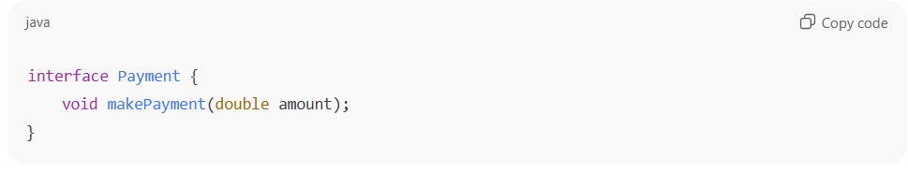
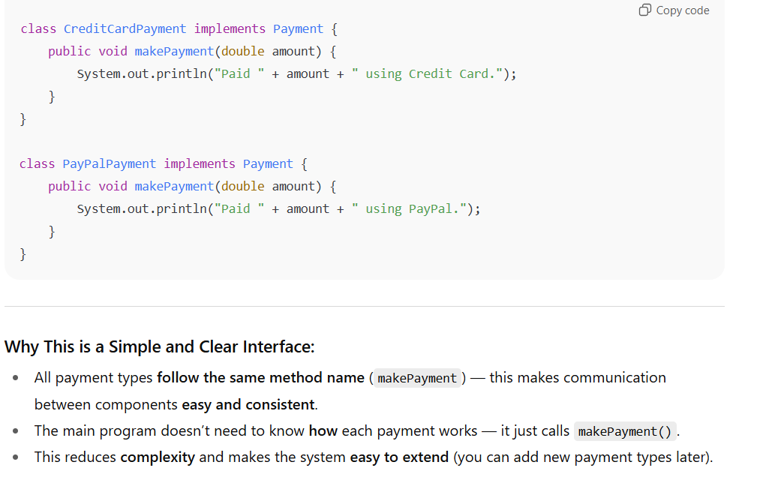
7. Systematic and Repeatable Design Process
The design should be created by following a clear and consistent step-by-step method, using information gathered during the requirement analysis stage.
This makes sure that every design decision is logical, well-documented, and can be traced back to a specific requirement.
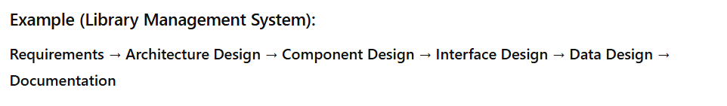
8. Effective Representation
The design should be shown with clear and simple diagrams or symbols so that everyone — like developers, testers, and clients — can easily understand how the system works.

Design Principles
1. Consider Alternative Approaches / Avoid Tunnel Vision
Don’t stick to only one idea. Before finalizing the design, always think about different ways to solve the problem.
Looking at multiple options helps you choose the best and most efficient design rather than just the first idea that comes to mind.
2. Traceability to Analysis Model
Your design should be linked to the analysis model, meaning every part of the design should come from the requirements gathered during analysis.
This makes sure that the design meets user needs and that nothing important is missed.
3. Don’t Reinvent the Wheel
Avoid creating things from scratch if a ready or tested solution already exists.
For example, use existing libraries, tools, or design patterns — this saves time, reduces errors, and makes the system more reliable
4. Minimize Intellectual Distance
Minimizing intellectual distance means that the software design should be as close as possible to the real-world problem it is solving. This means using real-world names and ideas that make sense to users.
For example, in a school management system, using words like “Student,” “Teacher,” and “Class” keeps the design simple and easy to understand.

5. Uniformity and Integration
A good software design should look and feel consistent throughout the system.
- It shows uniformity when the design seems like it was made by one person, even if a whole team worked on it.
- It is integrated when all parts of the system fit together smoothly, and the connections (interfaces) between them are well-defined and clear.
7. Review to Avoid Conceptual Errors
Designs should always be reviewed carefully to find and fix conceptual or meaning-related mistakes before moving to coding.
This ensures that the design correctly represents the intended system behavior and user requirements.
8. Design Is Not Coding and coding is not a design
Design and coding are not the same thing.
- Design is about planning and structure — deciding how the system will work.
- Coding is about implementing that plan using a programming language.
Even if the design goes into small details, it still stays at a higher level of abstraction than the actual source code.
9. Flexible for Change
The design should be made in a way that allows easy updates or changes in the future without breaking the whole system.
10. Graceful Degradation
Even if something unexpected happens (like wrong input or system error), the software should handle it smoothly instead of crashing.
11. Check Quality During Design
The design’s quality should be reviewed and improved while it’s being made, not only after it’s finished.
Data Abstraction
Data Abstraction means showing only the important details of data and hiding unnecessary information from the user.
It helps to simplify complex systems by focusing only on what is needed.
Example (Door)
When you use a door, you only see and use simple things like the handle or lock.
You don’t know how the lock mechanism works inside — that part is hidden.
Similarly, in programming, we hide data members (like isLocked) and only show methods (like lock() and unlock()) to use them safely.
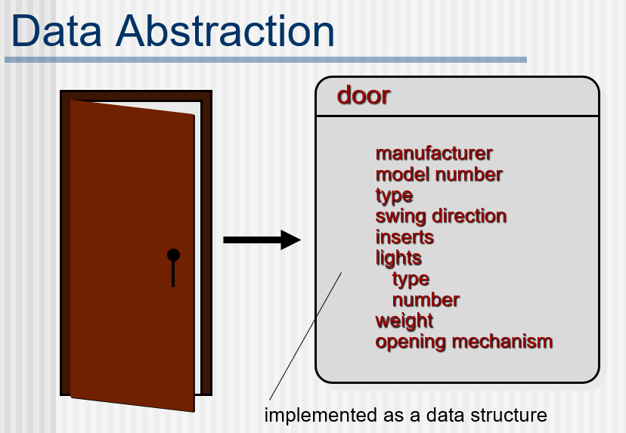
Procedural Abstraction
Procedural Abstraction means hiding the details of how a process (or function) works and only showing what it does.
It helps make programs simpler by focusing on the purpose of a function, not the internal steps.
Example (Door)
When you open a door, you just turn the handle — you don’t need to know the detailed steps inside (how the latch moves, how the hinges work).
In programming, you might call a method like openDoor() which performs many hidden steps internally, but you just use it easily.
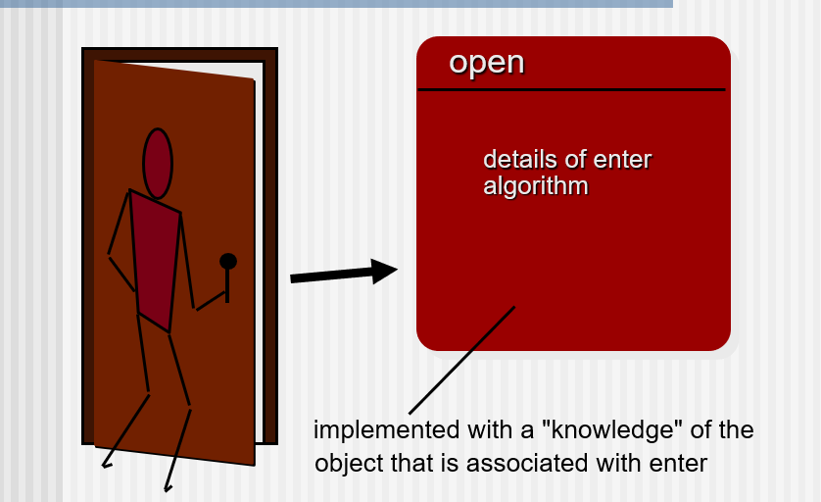
Architecture
Software architecture means the overall structure of the software and how this structure helps keep the system clear, consistent, and well-organized.
It shows how all main parts of the system fit and work together as one whole.
1. Structural Properties
This part of architecture explains the main components of the system (like modules, classes, or objects) and how they are grouped and connected.
For example, in object-oriented design, objects keep both data and the methods that work on that data, and they communicate with each other by calling (invoking) these methods.

2. Extra-Functional Properties
This part focuses on how software architecture meets quality requirements such as:
- Performance (how fast it works)
- Capacity (how much data or users it can handle)
- Reliability (how stable and error-free it is)
- Security (how safe the system is)
- Adaptability (how easily it can be updated or changed)
It basically ensures that the system not only works but also works well under different conditions.
3. Families of Related Systems
This means that the architecture should reuse common patterns or designs that have already worked well in similar types of systems.
It helps save time, reduce mistakes, and make the system more reliable by using proven design building blocks.
Patterns
A design pattern is a reusable solution to a common problem that arises often during software design. We use design patterns to provide proven, reusable solutions for common software design problems, saving time and improving code quality.
It acts like a template or guideline that helps developers solve problems quickly without starting from scratch every time.
Design Pattern Template
1. Pattern Name:
Gives a short and meaningful name that shows what the pattern is about.
2. Intent:
Explains what the pattern does and what problem it is meant to solve.
3. Also Known As:
Lists other names that this pattern might be known by.
4. Motivation:
Gives a simple example or situation showing the problem and how this pattern can solve it.
5. Applicability:
Tells when and where the pattern can be used — in what kind of design problems it helps.
6. Structure:
Shows the main parts (classes or components) needed to make the pattern work.
7. Participants:
Explains what each class or component does — their roles and responsibilities.
8. Collaborations:
Describes how the parts of the pattern work together to do their job.
9. Consequences:
Lists the results of using the pattern — its benefits and trade-offs (good and bad effects).
10. Related Patterns:
Mentions other patterns that are similar or often used along with this one.
Example
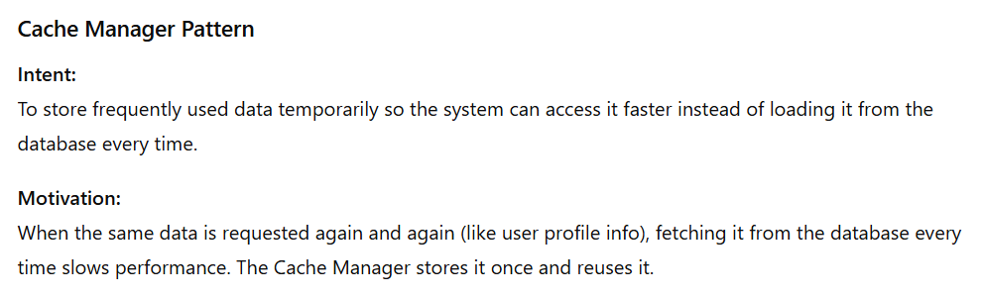
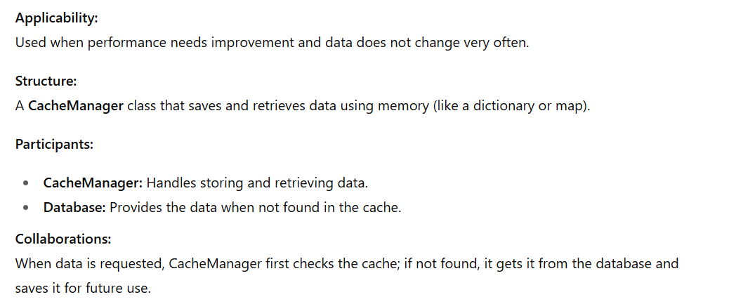
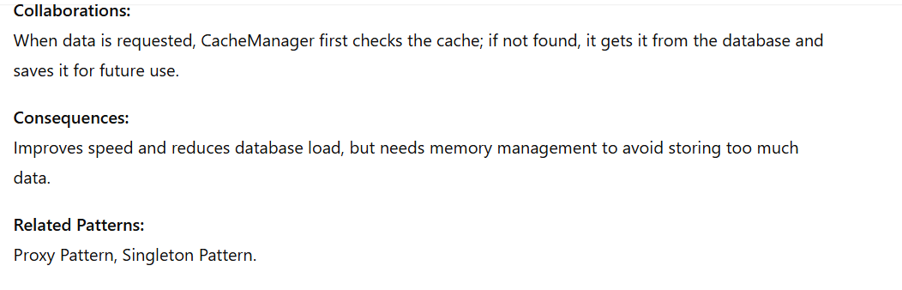
Separation of Concern (SoC)
Separation of Concern (SoC) is a software design principle that means dividing a problem or program into distinct sections, each handling a separate part of the functionality. Each “concern” is a specific responsibility or functionality, and the goal is to keep these concerns independent so that changes in one area have minimal impact on others.
Explanation:
Think of a restaurant:
- The chef cooks food.
- The waiter serves the food.
- The cashier handles payments.
Each person has a separate concern. If the cashier system changes, it doesn’t affect the chef.
Why It’s Useful:
- Make code easier to maintain: Each part handles a specific feature, so changes are easier to manage.
- Help reuse parts of code: Independent code pieces can be used in other programs or modules.
- Reduces bugs, because changes are isolated: Fixing one part won’t break other parts of the program.
- Improves readability and organization: Dividing code into logical sections makes it easier to understand and organize
Example in Programming:
In a web application:
- UI (frontend) handles user interface.
- Business logic (backend) handles calculations or rules.
- Database layer handles data storage.
Each layer has a separate concern, making the system easier to manage.
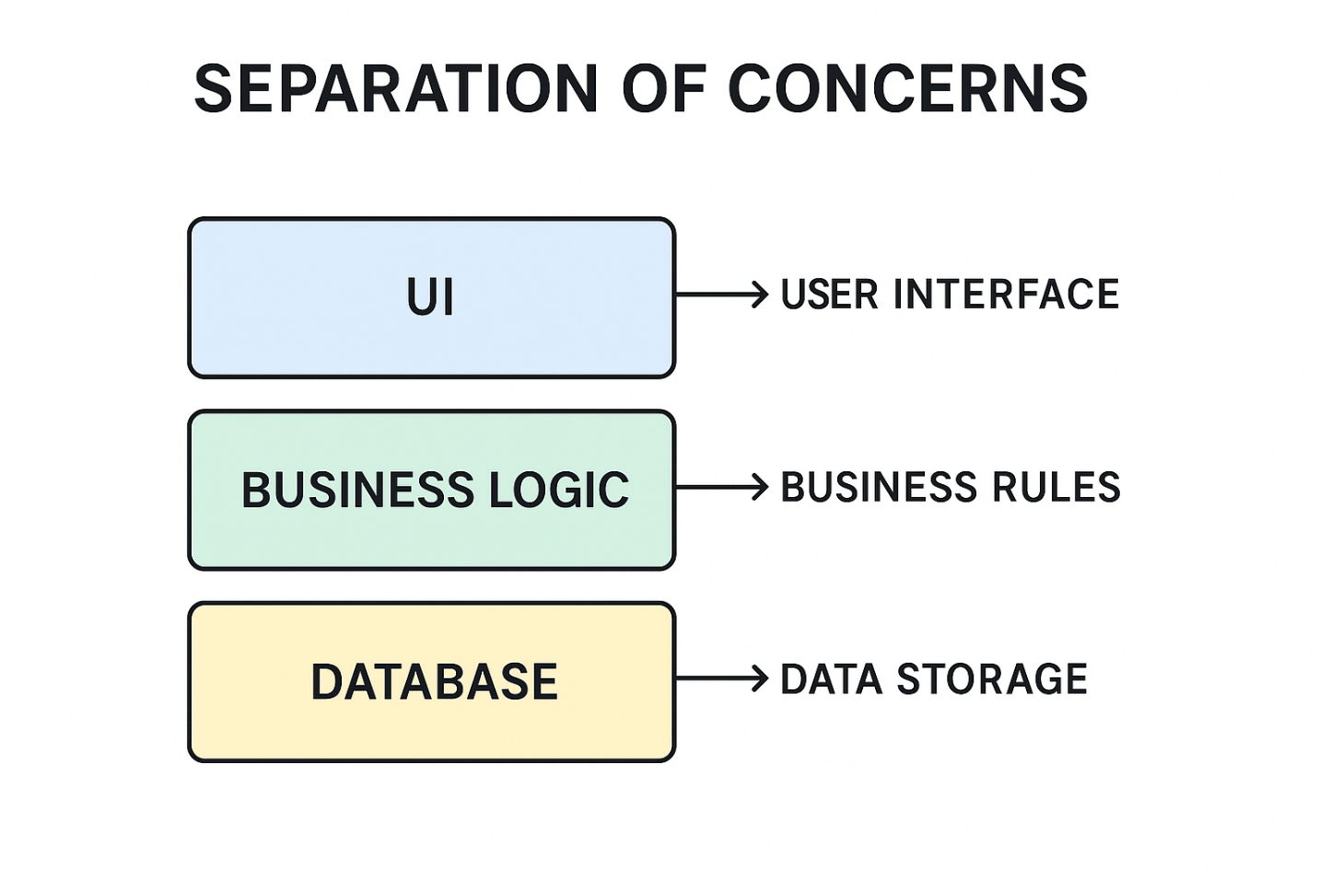
Modularity
Modularity is the quality of software that makes a program easier to understand and manage. A monolithic program, one big program with a single module—is very hard for a software engineer to grasp. Too many control paths, variables, and overall complexity make it almost impossible to understand.
In most cases, it’s better to break the program into smaller modules. This makes the software easier to understand and, as a result, reduces the effort and cost needed to build it.
Modularity: Trade-offs
Trade-off means giving up one thing to gain another — a balance between pros and cons. While modularity makes software easier to understand and manage, it also has some downsides.
When a program is divided into many small modules, combining them can take extra time and effort.
It may also slow down performance a little because modules need to communicate with each other.
So, there’s a balance — too few modules make the program hard to manage, but too many can make it complex to connect and test.
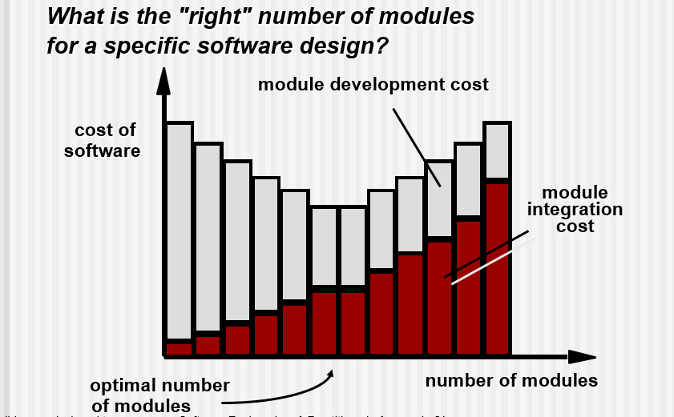
Bar Chart Breakdown
Red Bars: “Module Development Cost”
- As the number of modules increases, these bars get taller.
- Meaning: More modules = more effort to build and maintain each one.
Black Bars: “Cost of Software”
- These bars are taller when there are fewer modules.
- Meaning: Too few modules = messy, hard-to-manage software, which increases overall cost.
Information Hiding
Hiding information means keeping the internal details of a module private, so other parts of the program don’t depend on them. Each module shows only what is necessary to use it and hides how it works inside.
This helps prevent:
Prevents errors:
Since other parts of the program can’t directly change hidden data, they can’t accidentally break something inside the module.
Makes the program easier to change:
If you want to change how something works inside a module, you can do it without affecting other parts — because they don’t see or depend on the hidden details.
Keeps parts independent:
Each module works on its own and doesn’t rely on how others are built. This makes the whole program more organized and easier to manage.

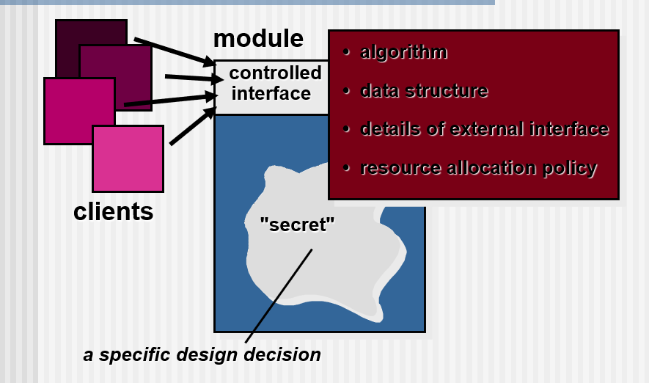
Why Information Hiding?
Reduces the likelihood of side effects:
When one part of the program is changed, it doesn’t accidentally cause problems in other parts. Each module works safely on its own.
Limits the global impact of local design decisions:
If you make a change inside one module, it affects only that module, not the entire program. This keeps the rest of the software stable.
Emphasizes communication through controlled interfaces:
Modules share information using specific methods or functions. This keeps data flow organized and prevents misuse of information.
Discourages the use of global data:
Data is kept private inside modules instead of being shared everywhere, which helps prevent unwanted changes.
Leads to encapsulation (a sign of good design):
Each module keeps its data and behavior together, protecting it from outside interference.
Results in higher quality software:
The overall program becomes easier to understand, test, and maintain — leading to fewer bugs and better performance
Sizing Modules: Two Views
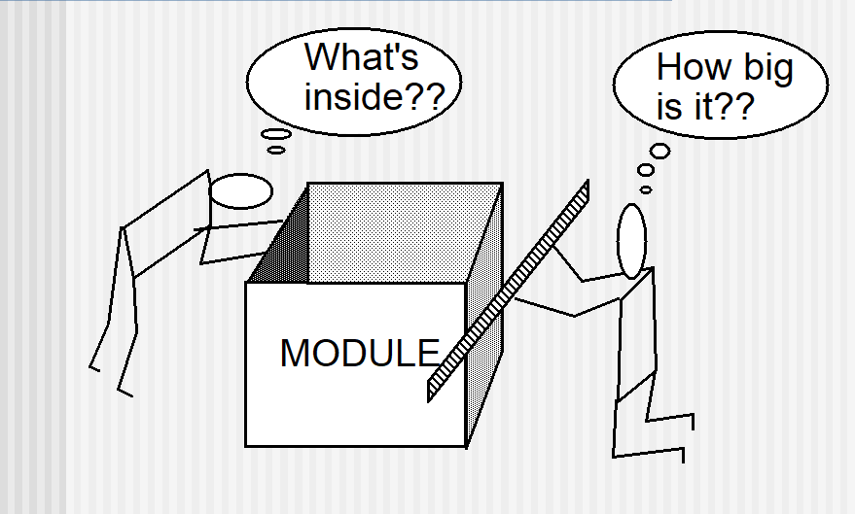
Left Side: “What’s inside??”
- This character is curious about the internal workings of the module.
- Represents the functional view:
  - What does the module do?
  - What algorithms, data structures, and logic are inside?
- This is about implementation details—how the module achieves its purpose.
Right Side: “How big is it??”
- This character measures the external size of the module.
- Represents the interface or usage view:
  - How many functions or endpoints does it expose?
  - How complex is it to use?
  - How much effort is needed to integrate it?
- This is about external complexity—how the module fits into the larger system.
Core Message:
To design good modules, you need to consider both views:
- Internally: Keep logic clean, efficient, and hidden (encapsulation).
- Externally: Keep interfaces simple, intuitive, and minimal.
Functional Independence
Functional independence means designing each module so it does one clear job and doesn’t depend too much on other modules.
A module should be “single-minded”, meaning it focuses on just one task, and it should avoid too much communication or dependency with other modules.
Cohesion
Cohesion shows how strongly the parts inside a module are related to each other.
A cohesive module performs one specific task and doesn’t need to talk much to other parts of the program.
In simple words, a module with high cohesion does one thing well.

Example
- High Cohesion:
A module that only handles user login — checking username and password.
It does one clear job.
- Low Cohesion:
A module that handles login, payment, and report generation together.
It does too many unrelated tasks.
Coupling
Coupling shows how much one module depends on other modules.
If modules are tightly coupled, they share too much data or rely heavily on each other — making the program hard to maintain.
If they are loosely coupled, they work more independently, which is better.
Example
- Low Coupling (Good):
A login module just calls a database module through a simple function like get-UserData().
They work together but stay independent.
- High Coupling (Bad):
A login module directly accesses the database module’s internal tables or variables.
If the database changes, the login code breaks too.

Increase cohesion where possible
A module or subsystem has high cohesion when it keeps together related tasks and does not mix unrelated ones.
This makes the whole system easier to understand, test, and modify, because each part has a clear purpose.
Type of cohesion
- Functional
- Layer
- Communicational
- Sequential
- Procedural
- Temporal
- Utility
1. Functional Cohesion
Functional cohesion happens when a module’s code is focused only on one specific task or computation, and everything unrelated is left out.
In other words, the module does one job, returns a result, and does not cause any side effects (like changing data elsewhere or interacting with the user).
Benefits to the System
- Modules with functional cohesion are easier to understand, because each one has a clear purpose.
- They are also more reusable, since the same module can be used in other programs that need the same function.
- Additionally, they are easier to replace or update, because changes in one module don’t affect others.

Example 1: Calculator Button (Functionally Cohesive)
When you press the “Add” button on a calculator, it only adds numbers and gives the result — nothing else.
It doesn’t print, store data, or open another function.
That’s functional cohesion — one clear job, one result.
Example 2: (Not Functionally Cohesive):
Modules that update a database, create a file, or interact directly with the user are not functionally cohesive — because they do more than one thing or cause side effects.
2. Layer Cohesion Means
Layer cohesion means grouping related tasks or services together in one layer of a software system.
Each layer has a specific role — for example, one layer handles the user interface, another handles business logic, and another handles data storage.
Unrelated things are kept out of that layer.
Hierarchy of Layers:
The layers are arranged in a hierarchy, like steps in a ladder.
- Higher layers can use the services of lower layers.
- Lower layers do not depend on higher layers.
Example
For example, in a web application:
- The UI layer (top) shows data to the user.
- The Logic layer (middle) processes data.
- The Database layer (bottom) stores data.
Here, the UI layer can use the logic layer, and the logic layer can use the database layer — but not the other way around.
API (Application Programming Interface)
Each layer provides its services through a set of defined procedures or functions, called an API.
The API is like a doorway that other layers use to interact with it.
Easy to Replace Layers
If you ever need to change or update a layer (for example, switch to a new database), you can do it without changing the other layers. But If the new layer uses the same names and methods (API) to talk to other layers as the old one did,
then the other layers won’t notice any difference — so nothing else needs to change.
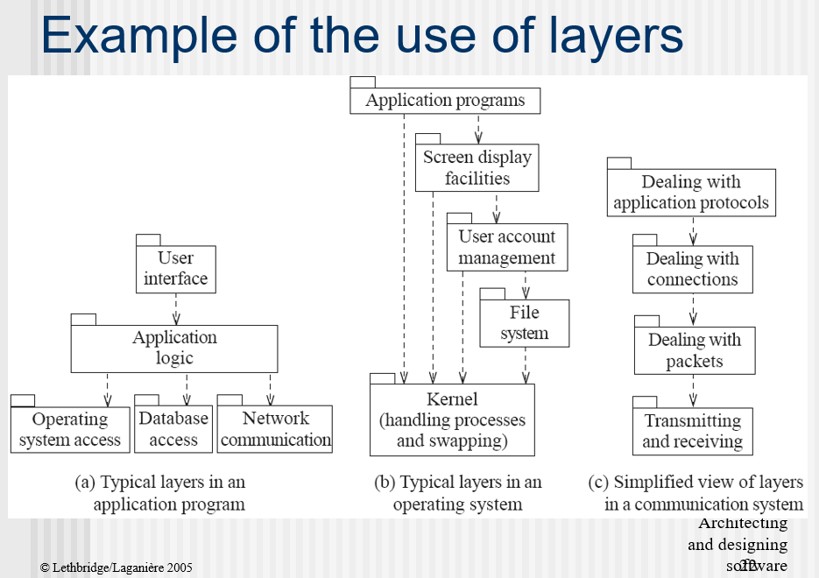
3. Communicational Cohesion
Communicational cohesion means that all parts of a program that work with the same data are kept together, and anything unrelated is left out.
A module or class shows good communicational cohesion when it:
- Stores and manages specific data (like student records or product details).
- Only handles tasks related to that data — nothing else.
Main advantage:
When you need to update or fix something related to that data, you can find all the relevant code in one place, which makes the program easier to understand and maintain.
4. Sequential Cohesion
Sequential cohesion means that the output of one part becomes the input for the next part — like a chain of steps that depend on each other.
All these related steps are kept together in one module, and anything not part of the sequence is left out.
You should aim for sequential cohesion only after achieving the earlier, stronger types of cohesion (like functional or communicational).
Example
When processing an order — first check the item, then calculate the bill, then print the receipt.
Each step uses the result of the previous one — that’s sequential cohesion.

5. Procedural Cohesion
It means the parts of a module are grouped together because they always run one after another in a specific order, even if the output of one part is not used by the next.
It just follows a procedure or sequence of steps, not a strong logical connection.
Example:
A module that:
- Opens a file.
- Reads data.
- Prints a message.
Here, these steps are done in order, but printing the message doesn’t depend on reading data — they just happen one after another.
6. Temporal Cohesion
It means the parts of a module are grouped together because they happen at the same time — usually during a specific phase of the program (like start-up or shutdown).
These tasks are done together not because they are related by data or purpose, but because they must all happen at that time.
Example:
When a mobile app starts, a module might:
- Connect to the internet.
- Check user login status.
- Load the home screen.
All these actions happen during app start-up, so they are grouped together — even though they do different things.
7. Utility Cohesion
It means putting together general-purpose functions that can be used in many different parts of a program, even though they don’t belong to one specific task.
These are helper functions that make work easier and can be reused anywhere.
Example:
A module that contains:
- A function to find the maximum of two numbers
- A function to calculate a square root
- A function to round off a number
All these are useful in many programs, not just one — like the Math class in Java (Math.max(), Math.sqrt(), etc.).
Scenario
Categorize the following aspects of a design by the types of cohesion that they would exhibit if properly designed:
- All the information concerning bookings is kept inside a particular class, and everything else is kept out.
- A module is created to convert a bitmap image to the JPEG format.
- A separate subsystem is created that runs every night to generate statistics about the previous day’s sales.
- A data processing operation involves receiving input from several sources, sorting it, summarizing information by input source, sorting according to the input source that generated the most data and then returning the results for the use of other subsystems. The code for these steps is all kept together, although utilities are called to do operations such as sorting.
Answers
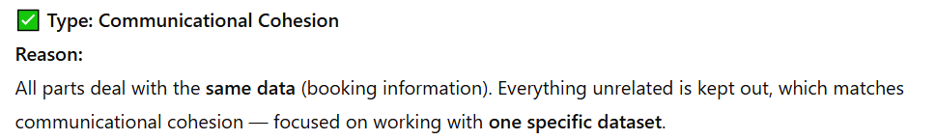
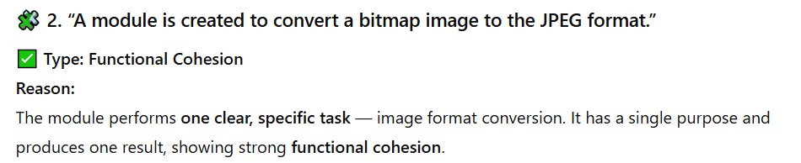
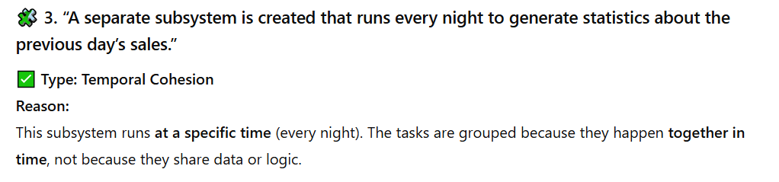
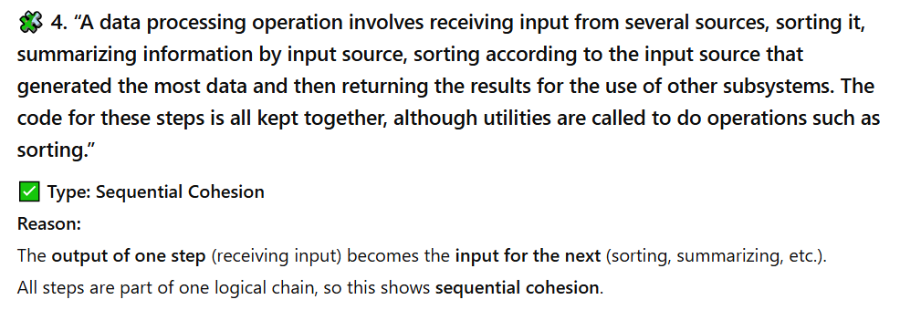

Reduce coupling where possible
Coupling means how much one module depends on another in a program.
When two modules are tightly connected, a change in one often affects the other, which makes the system harder to understand and maintain.
So, we try to reduce coupling — make modules work more independently.
Types of Coupling
- Content
- Common
- Control
- Stamp
- Data
- Routine Call
- Type use
- Inclusion/Import
- External
1. Content coupling
This happens when one module directly changes or uses the internal data (like variables) of another module instead of using proper methods.
It’s a very bad type of coupling because it breaks the idea of encapsulation — one module secretly messes with another’s data.
Example:
A module directly changes another module’s variable or code.

2. Common Coupling
This happens when many modules share the same global variable.
If one module changes that variable, it can affect all other modules that use it — making the system harder to understand and maintain.
Example:
Multiple modules using the same global variable.
3. Control Coupling
Control coupling occurs when one module controls the behavior of another module by passing control information, such as flags, codes, or parameters that tell the other module what to do.
If you change the control logic, you’ll have to change both modules — making the system harder to update.
Example:
For example, if one module passes a flag or code to another module to tell it what operation to perform (like “1 for add, 2 for subtract”), then control coupling exists between them.
4. Stamp coupling
Occurs when:
One class passes an entire object to another, even though the receiving class only needs part of the data.
This makes both classes dependent on the same data structure.
If the object’s structure changes, both must change
Example:
Passing an entire object or record when only one field is required.

5. Data coupling
Data coupling happens when modules share data only through simple arguments — like numbers, strings, or small library types.
This is a good and low level of coupling, because modules only exchange the data they need, and nothing more.
However, if a method has too many arguments, the coupling still increases, because every module that calls it must pass all those arguments.
Example:
Passing simple data values like numbers or strings between modules.

6. Routine Call Coupling
This happens when one method or routine calls another to get some work done.
It means the two routines are connected — the caller depends on the other’s behavior or result.
This type of coupling is normal and unavoidable in most programs, because methods usually need to call each other to complete a task.
Example
A “Billing” method calls a “Calculate Total” method to get the amount to charge.
The “Billing” method depends on “Calculate Total” to give the right value — so they are routine call coupled.
How to reduce it:
If you find that you always call the same set of methods together (for example, Method A → Method B → Method C),
you can combine them into one single method that performs the whole sequence.
This reduces the number of direct calls and makes the code easier to manage.
7. Type use coupling
Type use coupling happens when a module or class uses a data type that’s defined in another module or class.
In simple terms, one class depends on another because it uses it as a variable type — for example, by declaring an object of that class.
Example (in theory):
Imagine a PaymentProcessor class that has a variable of type CreditCard.
If the CreditCard class changes (for example, you rename a method or add a new parameter),
then the PaymentProcessor class may also need changes — that’s type use coupling.
Consequence:
If the type definition changes, every class that uses that type may need to be updated —
this makes the system harder to modify or extend.
How to reduce it:
Always declare variables using the most general type or interface that provides the operations you need,
instead of a specific class.
For example:
Use PaymentMethod (interface) instead of a concrete type like CreditCard.
That way, if you later add new types (like PayPal or DebitCard), you don’t need to change the existing code.
8. Inclusion or import coupling
This happens when a class or module includes or imports another file, package, or library.
It means your component now depends on everything inside that imported or included component.
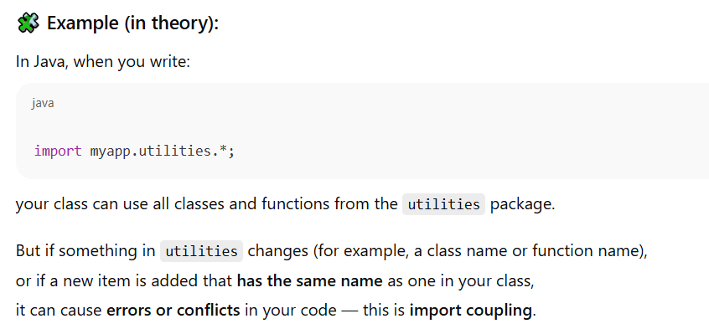
Problem:
- Your class becomes dependent on another component’s structure.
- Any change in the imported file might force you to update your class.
- Naming conflicts can occur if both files define items with the same name.
9. External Coupling
External coupling happens when your program depends on outside systems or resources — like the operating system, hardware, or external libraries.
This means your code can only work correctly if those external parts behave as expected.
If the external system changes (for example, a new OS version or a different hardware setup), your program might stop working properly.
Example
Imagine your program directly reads data from a printer.
If the printer driver changes your program fails.
That’s external coupling, because your code depends on an outside thing.
Problem:
- Your system becomes less portable (harder to run on different computers).
- Harder to test because you need the real external system.
- Any change in the external system can break your code.
How to reduce it:
- Use a Façade design pattern — create one simple module that handles all communication with external systems.
Then, if something changes outside, you only need to update the façade, not the whole program.
- Try to isolate or wrap external dependencies in one place.

Lecture 06
Data Flow Architecture
Overview
In the data flow architecture, the software works step by step, like water flowing through a pipe.
- Data moves from one step to another.
- Every step takes some data, does something simple to it, and then sends the new data forward.
- Each step doesn’t worry about how other steps work.
It only cares about the data it gets and the data it gives.
- The data and the steps are kept separate, so changing one step does not break others.
- In general, there is no interaction between the modules except for the output and the input data connections between subsystems.
- This means every subsystem works independently.
You can replace one subsystem with another, and the rest of the system will still work— if the input and output data format stays the same.
Note: Data Flow architecture is logical representation having no practical implementation means it shows how data moves and is processed, without specifying physical implementation details."
Architecture Types
There are two ways these modules can run:
- Batch Sequential
- Pipe and filter
- Process control
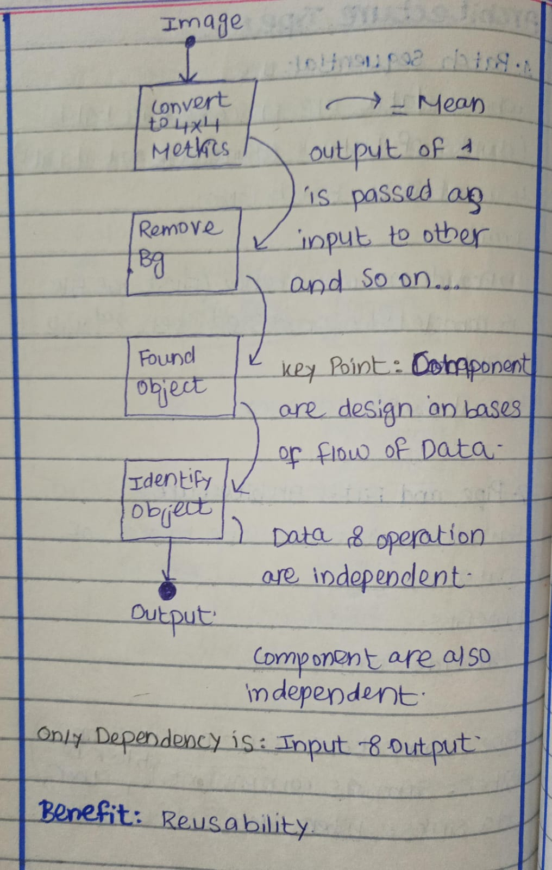
Batch Sequential Architecture
- Data is sent in batches, meaning a group of data items is processed together as a single unit from one module to the next, rather than one by one
- In batch sequential architecture, the system is divided into modules or subsystems.
- Each module waits for the previous module to finish its work before it can start.
Example:
Bank Transactions (Batch Processing)
- Collect transactions during the day.
- Group them into a batch at the end of the day.
- Process the batch to update all account balances.
- Generate reports for the day.
Key point: Each module works one after the other, and the data moves in groups (batches), not continuously.
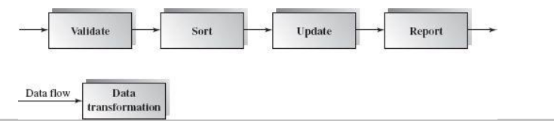
Batch sequential (cont.)
- In this architecture, subsystems do not send data directly to each other.
- Instead, they store data in temporary files (called intermediate files).
- The next subsystem reads that temporary file, uses it, and then the file can be deleted because it’s no longer needed.
Where it is used?
This style is common in business systems like banking, electricity billing, and other monthly or daily processing tasks, where data is handled in batches.
Applicable Domains
- This architecture is useful in areas where data is collected and processed in batches, not continuously.
- The temporary file used between steps is a sequential file, meaning data is read and written in order, one record after another.
Each subsystem:
- Reads the input data from these intermediate files
- Processes it
- Then writes its output into another file for the next subsystem to use
Benefits and Limitations of Batch Sequential
Benefits
- The system is easy to divide into clear subsystems or steps.
- Each subsystem can work as a separate program:
  - It takes input data
  - Processes it
  - Produces output
- This makes the system simple to understand, develop, and maintain.

Limitations
- It does not allow user interaction while processing (no real-time interface).
- No concurrency: subsystems cannot run at the same time — they must wait for each other.
- Because of this, the system has low throughput (slow overall processing).
- It also results in high latency, meaning the output takes longer to be produced.
Pipe and Filter Architecture
Pipe and filter is another type of data flow architecture where the system works by passing data from one component to the next. But it works on Works on Stream of Data.
- As soon as a filter gets some part of the data (not the whole set), itstarts processing.
- Data flows continuously through pipes — like water in a pipeline.
- This allows parallel work since each filter can process its part at the same time.
The whole system is divided into:
- Data sources: where data comes from
- Filters: components that process or transform the data
- Pipes: connections that carry data between filters
- Data sinks: where the final output goes
A special advantage of this architecture is that filters can run at the same time (concurrent execution). As soon as one filter produces data, the next filter can start working. This increases speed and efficiency.

Pipe and Filter Architecture (Conti.)
- A filter doesn’t need to wait for the whole batch of data.
- As soon as some data arrives through the pipe, the filter can start working immediately.
- A filter doesn’t care where the data comes from (upstream) or where it goes next (downstream).
- Each filter only works on its own small piece of data as it arrives (local and incremental processing).
- A pipe is used to send a stream of data from one filter to the next.
- A pipe can carry data in binary form or as character/text stream
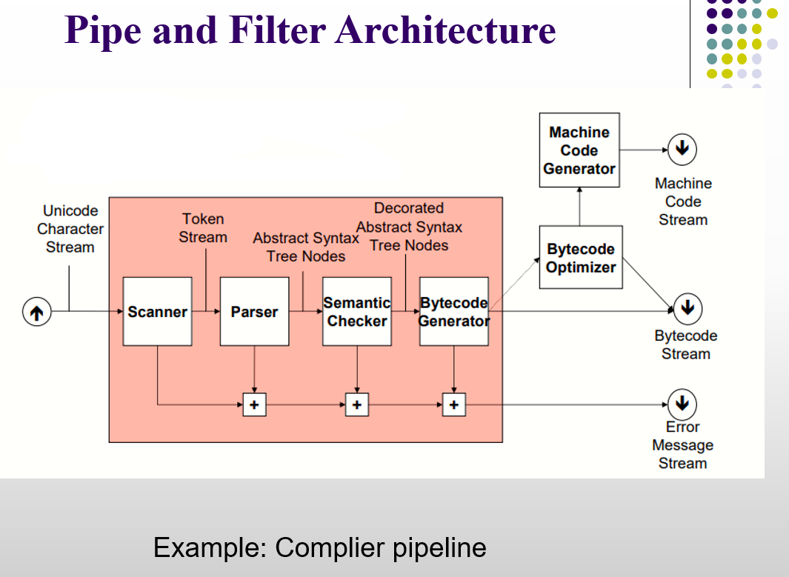
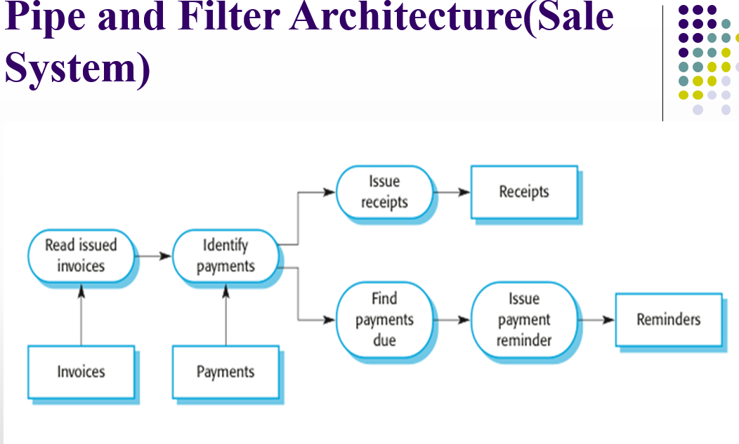
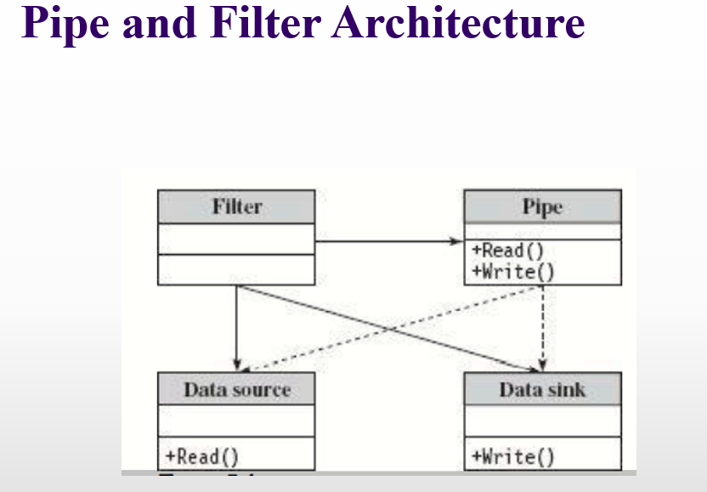
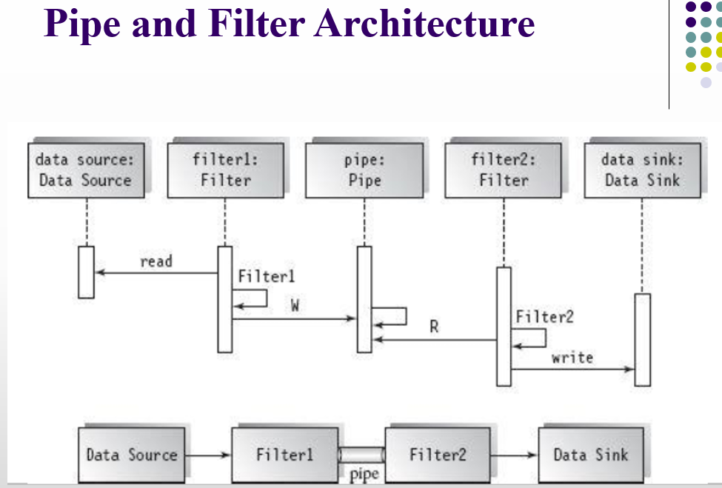
Pipe and Filter Architecture
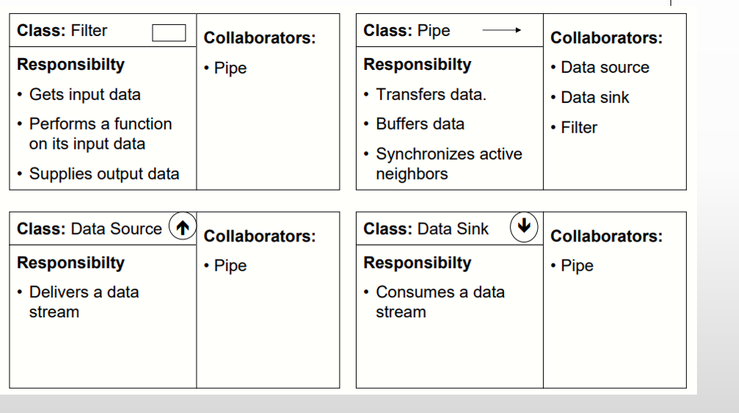
Applicable Domains
- This architecture works well when a system can be divided into multiple small processing steps, where each step (filter) reads data bit by bit and processes it as the stream flows.
- The data flowing in the stream should have a simple and consistent format, and it should be easy to change or adjust the format if needed.
Benefits
- Concurrency: Filters can work at the same time, so the system can handle large amounts of data quickly.
- Reusability: Each filter is independent, so you can reuse it in different systems or replace it easily.
- Modifiability: Filters are loosely connected, so adding new filters or changing existing ones has little impact on others (as long as input/output stays the same).
- Simplicity: Each filter is clearly separated from the next by a pipe, making the system easy to understand.
- Flexibility: The system can run sequentially or in parallel, depending on needs.
Limitations
- Performance overhead: Data passes through pipes, which can slow the system.
- Rigid data flow: Difficult to implement loops or branching. Because in pipe and filter, data flows in one direction only — from one filter → pipe → next filter. There is no built-in mechanism for sending data back to a previous filter or skipping filters conditionally.
- Limited interaction: Filters can’t easily share state or communicate. Each filter is independent and only knows about the data coming through its input pipe. Filters cannot easily share variables, memory, or state with other filters.
Process Control Architecture
Process Control Architecture is a software architecture style used to monitor, control, and automate real-world processes. It’s common in systems like industrial automation, robotics, and embedded control systems. It uses three main types of data:
Controlled Variable
- The target or goal value the system wants to maintain.
- Air Conditioner: Desired room temperature (e.g., 22°C).
- The system measures these using sensors and compares it to the set point (the desired goal).
Input Variable
- This is what the system senses from the environment.
- Example: The current room temperature is measured by the thermostat, e.g., 25°C.
Manipulated Variable
- This is the value that the controller can adjust to reach the desired goal.
- Example: Turning the AC cooler ON or OFF or adjusting the cooling level to reach the set temperature.
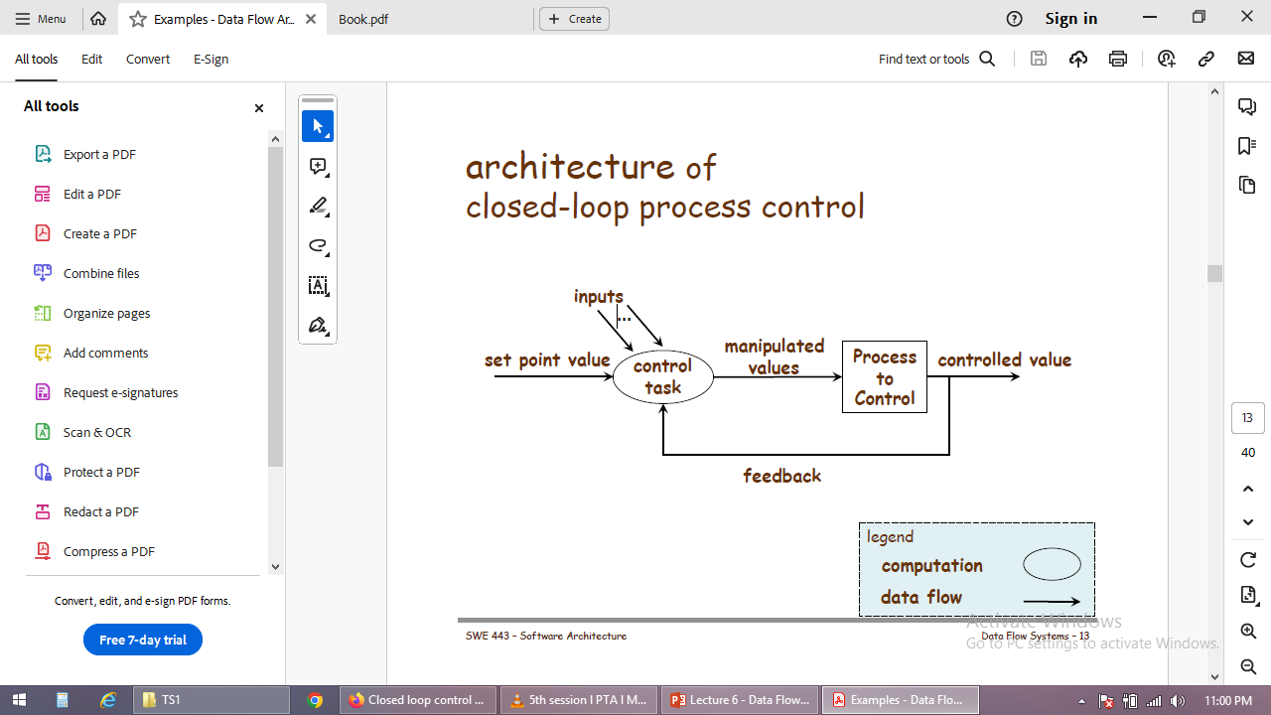
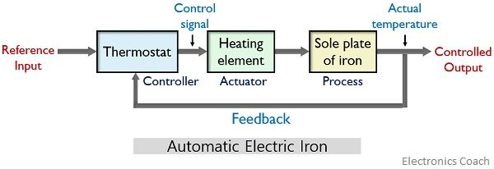
Benefits
Handles complex control situations:
- Useful when there is no exact formula to decide how to adjust the manipulated variable.
- The system can dynamically decide the best adjustment based on feedback.
Embedded software:
- The control logic can be fully embedded in devices like ACs, cars, or industrial machines.
- No separate computer is needed; the device can control itself automatically
Note: PCA is used where we don’t frequently interact with the system

Lecture 07
Data Centered Architecture
Data-centered Architecture
This architecture uses a central place to store data that all other parts of the software can use.
Main idea: One big data storage that everything can read from and write to.
Two Main Components:
- Central Data Store / Repository:
- The “main memory” of the system.
- Keeps data safe and permanent.
- Data Accessors / Components:
- Independent parts of the system that use the data.
- They can read, process, and update the data.
Two Types of Data-Centered Architecture:
- Repository:
- All components share the same data store.
- Example: A library database where all apps access the same books data.
- Blackboard:
- Components write information on a shared blackboard and others can read it.
- Example: Speech recognition system

Repository Architecture
Repository architecture is a software design pattern where a central data repository is used, and all components communicate through it rather than directly with each other.
When different parts of a system need to share data, they can do it in two ways:
- Central Repository: All parts use a common database to read and write data.
- Separate Databases: Each part has its own database and sends data to other parts when needed.
If a lot of data needs to be shared, using a central repository is the most common and efficient way.
Repository Architecture
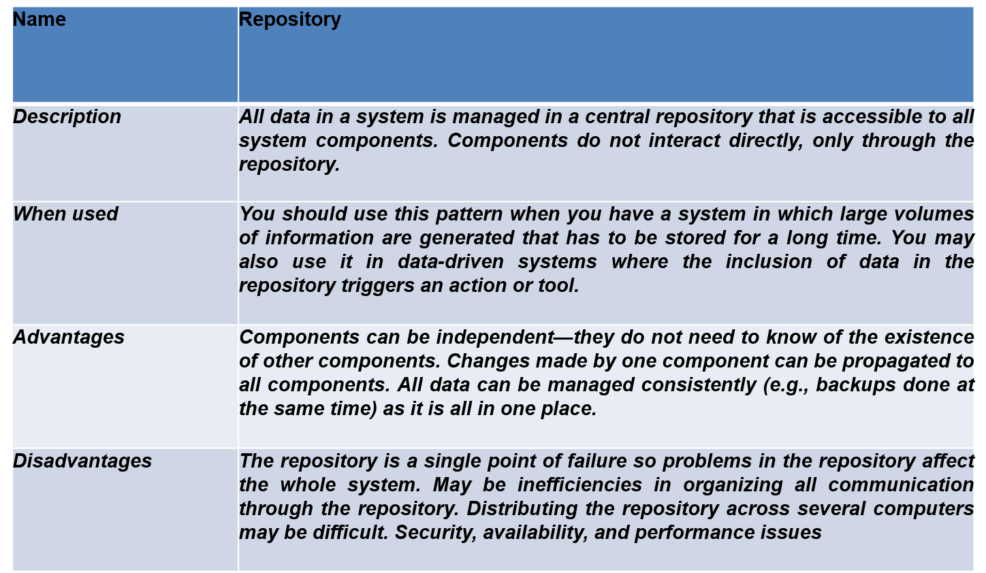

Repository Architecture
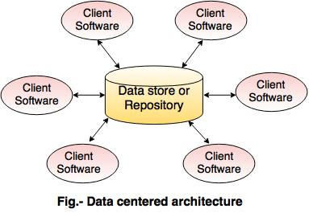
Advantages:
- Centralized data management – all data is in one place for easy access.
- Easy to maintain and update – changes in the repository reflect everywhere.
- Promotes data consistency – all components use the same source of truth.
Disadvantages:
- Single point of failure – if the repository fails, the whole system may stop.
- Can become a performance bottleneck – too many requests slow it down.
- Harder to scale – adding more users or components can overload the repository.
Blackboard Architecture
- The data store (blackboard) is active, and the clients just wait for updates.
- The system’s flow depends on what data is currently in the blackboard.
- Components talk only through the blackboard, not directly to each other.
- The blackboard notifies clients whenever the data changes.
Blackboard Architecture
- This approach is used in AI and complex systems, like speech recognition, image recognition, and business management systems.
- A key difference from traditional databases is that in blackboard architecture, components act based on the current data in the blackboard, not because of external inputs.
Parts of Blackboard Architecture
The blackboard model is usually presented with three major parts
- Knowledge Source (KS): Components that analyze or modify data on the blackboard.
- Blackboard Data Structure: The central data store where all information is kept.
- Control: The mechanism that decides which KS acts next based on the blackboard’s state.
Knowledge Sources (KS):
- KS, also called Listeners or Subscribers, are separate and independent units.

Knowledge Sources (KS)
- Each KS is a specialist at solving a certain part of the problem.
- A KS doesn’t need other KSs to do its work.
- Once it finds the information it needs on the blackboard, it works on it independently.
- KSs can be added, removed, or changed without affecting others.
- A KS acts only when the blackboard’s state requires it.
- KSs interact only through the blackboard, not directly with each other.
Blackboard Data Structure
- The blackboard stores all the data.
- Knowledge Sources update the blackboard, gradually working toward a solution.
Control:
- Control manages tasks and monitors the progress of work.
- It can be implemented in knowledge sources, the blackboard, externally, or a mix of these.
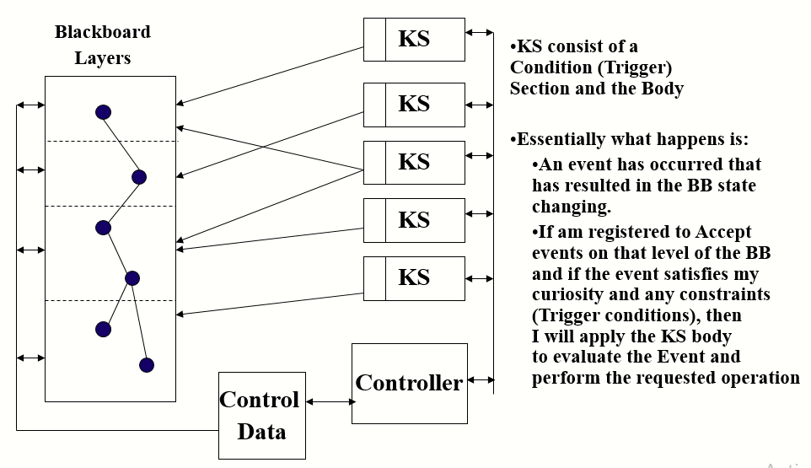
Blackboard Architecture
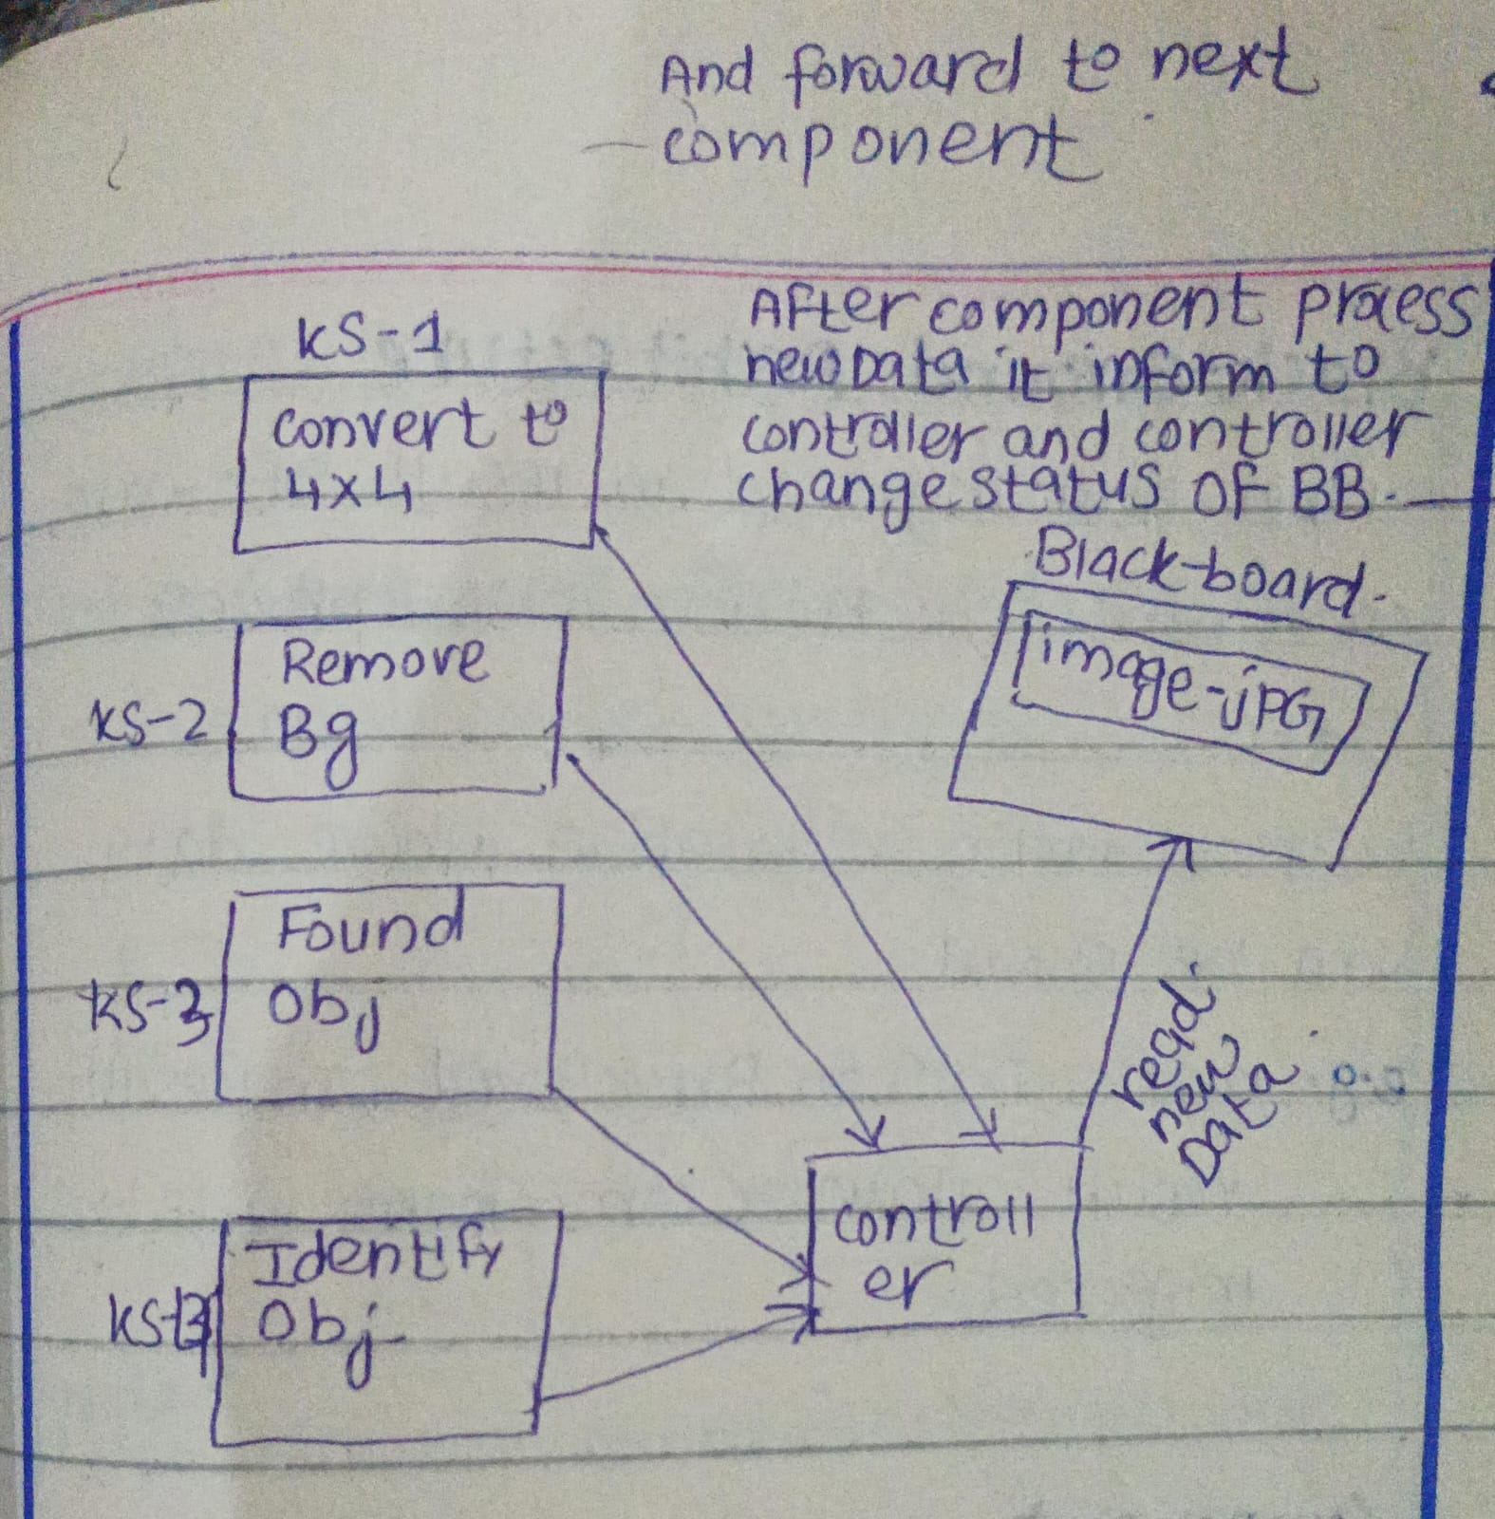
Blackboard Architecture
Advantages:
- It gives a clear place to manage data sharing, coordination, and task distribution.
- Scalable: knowledge sources can be easily added or updated.
- Supports parallel work: multiple knowledge sources can work at the same time independently.
- Reusable: knowledge source agents can be reused in other systems or problems.
Disadvantages:
- If the blackboard structure changes, it can affect all knowledge sources.
- It’s hard to know when to stop the process. In blackboard systems, the solution is built step by step. Each Knowledge Source adds partial or approximate results, not a final answer.
There is no clear signal that says, “the final solution is complete.” So, the system may keep improving the solution, and it becomes hard to decide when to stop reasoning.
- Synchronization is difficult since many agents update the blackboard at the same time and must be coordinated.
- Debugging and testing the system is hard due to many interacting agents.
Blackboard Architecture
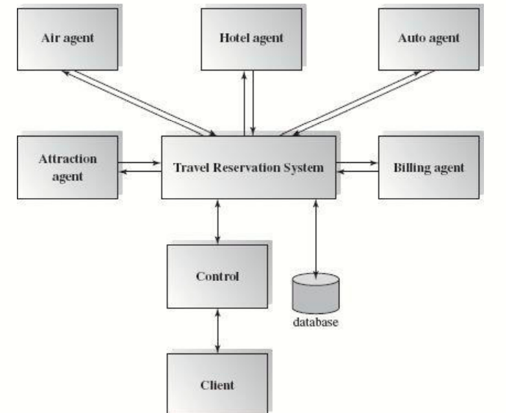
Lecture 8
Hierarchical Architecture
Topics
Styles
- Main / Subroutine
- Master / Slave
- Layered
- Virtual
Advantages and Disadvantages
Overview
- A layered system is arranged in levels where each layer works with the layer just above and below it.
- Each layer gives services to the upper layer and takes services from the lower layer.
- In some systems, inner layers are hidden and can only be used by nearby layers.
- Layers communicate using defined rules called connectors or protocols.
- One important rule is that layers usually interact only with adjacent layers.
- A well-known example is the OSI-ISO communication model.
- Lower layers deal with hardware and connections, while higher layers handle applications.

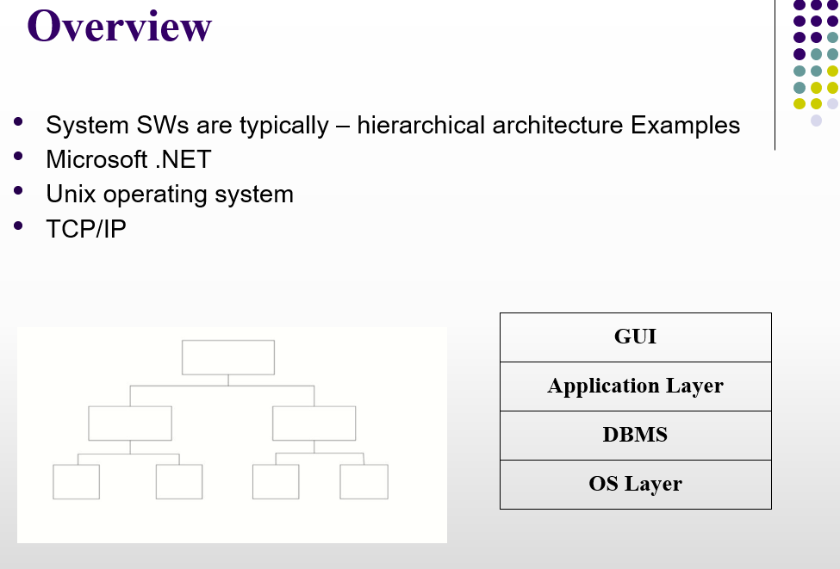
General Rules
Lower layers provide basic and core services like input/output, security, scheduling, and transactions.
Middle layers handle main system work such as business logic and core processing.
Upper layers focus on user interaction, like command line, graphical interface (GUI), or shell programs.
Plus Point:
If a change is made in one layer, it usually affects only the layers next to it.
This prevents big changes across the whole system and makes maintenance easier.

Advantages and Disadvantages
Advantages
Easy to Understand: Layered systems are simple to understand because they are designed step by step, from basic layers to advanced layers.
Better Problem Breakdown: Large and complex problems are divided into smaller parts, making them easier to design and manage.
Easy to Improve and Maintain: Updates or changes are easier because each layer communicates with only nearby layers.
Disadvantages
Lower Performance: Layered systems may be slower since requests must pass through many layers.
Hard to Define Layer Responsibilities: It can be difficult to decide what work belongs to each layer, especially in older systems where layers are mixed.
Main / Subroutine Architecture
Overview
Main/Subroutine architecture is one of the oldest and most commonly used system designs.
Purpose
Its main goal is to encourage reuse of code modules.
Idea
The whole system is divided into small parts called subroutines.
A main program controls the flow and calls these subroutines to complete tasks step by step.

How Sub-routine Call is Supported
Function Call Supported by High Level Language
- Parameter passing
- Pass by value
- Pass by reference
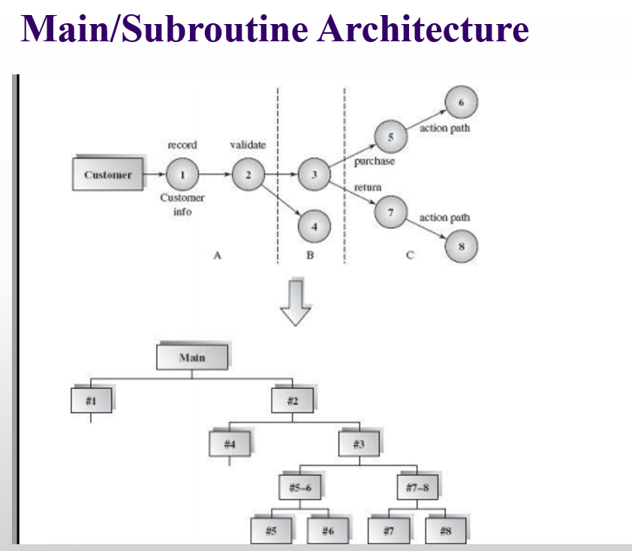

Main/Subroutine Architecture
Benefits:
Easy System Breakdown: Easy to decompose the system
Easy Testing: Each subroutine can be tested separately, making debugging simpler.
Code Reusability: Subroutines can be reused in different parts of the program, which saves time and effort.
Limitations:
Risk with Shared Data: Data shared globally can be unsafe and may be changed by many parts of the system.
Tight Coupling Problem: Subroutines depend heavily on each other, so a small change in one part can affect many other parts.
Master-Slave Architecture
Overview
Master-Slave architecture is a type of Main-Subroutine design.
Purpose
It helps improve fault tolerance (If one slave fail other can provide services) and system reliability.
How it Works
- Slaves perform tasks or provide services for the master.
- The master collects results from the slaves and chooses the best one using certain rules.
- Slaves can do the same task in different ways or handle completely different tasks.
- This setup ensures the system keeps working even if some slaves fail.
Note: The master can write or update data and slaves can usually only read data.
Master-Slave Architecture
Characteristics:
- Supports parallel computing (tasks can run at the same time).
- Ensures accurate results by comparing outputs from multiple slaves.
Applicable Domain:
Used in systems where high reliability is important.
Examples:
- Master-Slave in Jenkins – Master schedules jobs, slaves execute them.
Master-Slave Database
- There is one master and many slaves.
- It helps speed up reading and optimize input/output operations.
- The master is the main caretaker of data and holds the original information.
- Writing or updating data happens only in the master.
- Slaves handle all read requests from users.
Goal of Master-Slave Architecture
The main goal is to keep the system reliable even under heavy usage.
- If a website has only one master database, it can get overloaded with both read and write requests.
- Using two types of databases—one master for writes and one or more slaves for reads—balances the load.
- This setup scales the application, making it faster and more reliable for many users.
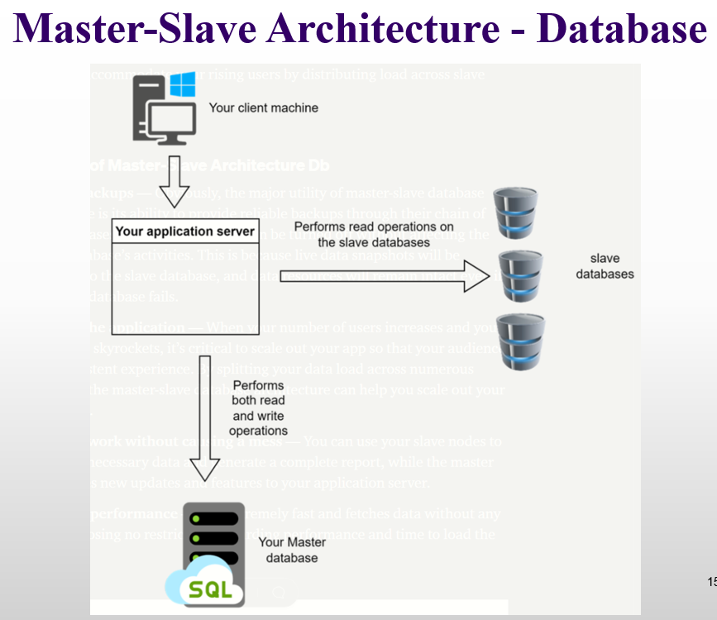
Master-Slave Architecture – Database
Advantages
Reliable Backups: Slaves keep copies of data, so turning off a slave or even master failure won’t lose data.
Scales Easily: Distributes work across multiple databases to handle more users.
Organized Workload: Master handles updates, slaves handle reading, avoiding confusion.
High Performance: Fast data access with no major delays.
Disadvantages
Replication Can Fail: Sometimes, when the master changes data, those changes don’t reach the slaves if the master breaks because the master updates first and the slaves get updated later.. So, it’s not always reliable.
Hard to Handle Many Writes: The master can get overloaded if too many write requests come at once. To fix this, the master’s computer needs better CPU and memory.
No Automatic Backup Master: If the master stops working, one of the slaves has to be manually made the new master. It doesn’t happen by itself.
Extra Work for the Master: Slaves copy data from the master’s log, which puts more work on the master.
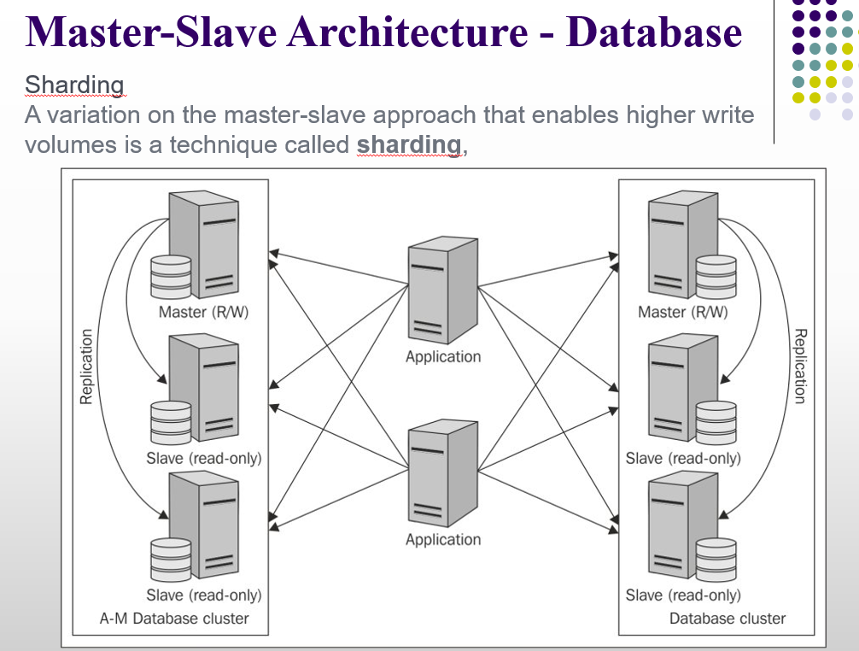
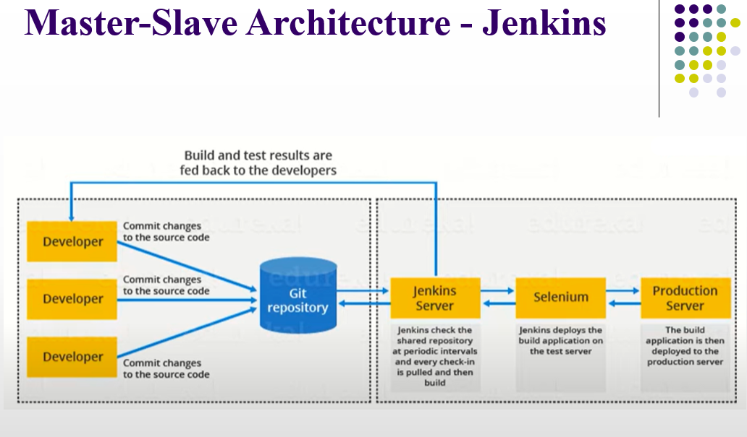
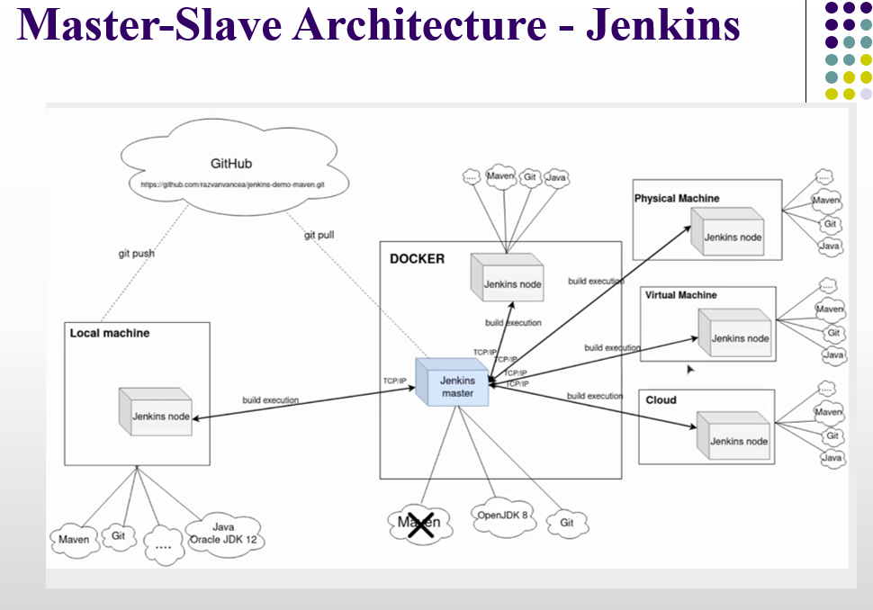
Jenkin
Jenkins is a tool that automates software tasks like building, testing, and deploying code. It supports Continuous Integration (CI) to check and test code automatically, and Continuous Delivery (CD) to deploy code.
Layered Architecture
- It is one of the most common ways to design software.
- Parts of the system that do similar work are grouped into layers.
- You can have any number of layers, depending on what the system needs.
- Layers help separate responsibilities, so each part has a clear job.
- Abstracts the view of the system as a whole while providing enough detail to understand the roles and responsibilities of individual layers and the relationship between them.
Layered Architecture
Layers are connected using function calls, queries, data objects, or other ways to send requests or information.
Common layers are Presentation, Business/Logic, and Data/Physical.
1. Presentation Layer – Handles the user interface and browser communication. This is the only layer the user directly interacts with.
2. Business/Logic Layer – Contains the main application logic like computations, data processing, and query handling.
3. Data/Physical Layer – Stores information. The logical schema shows the data structure conceptually, while the physical schema implements it in a database.
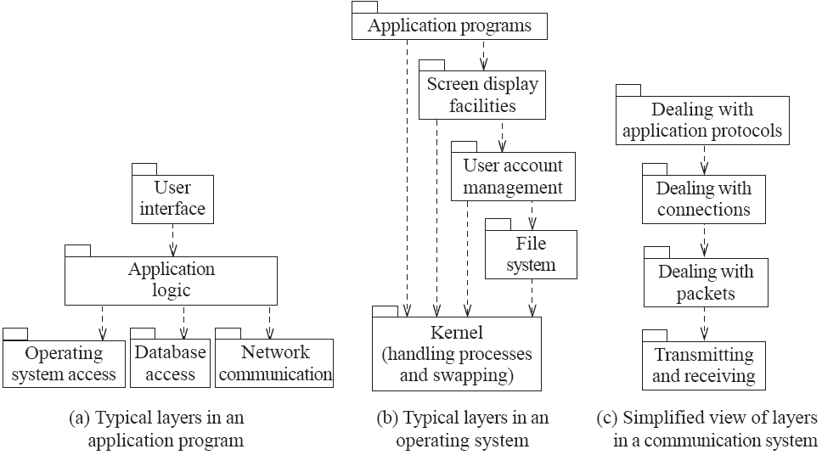

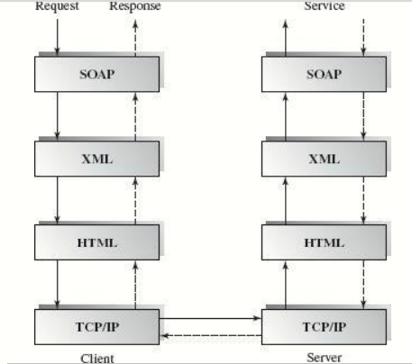
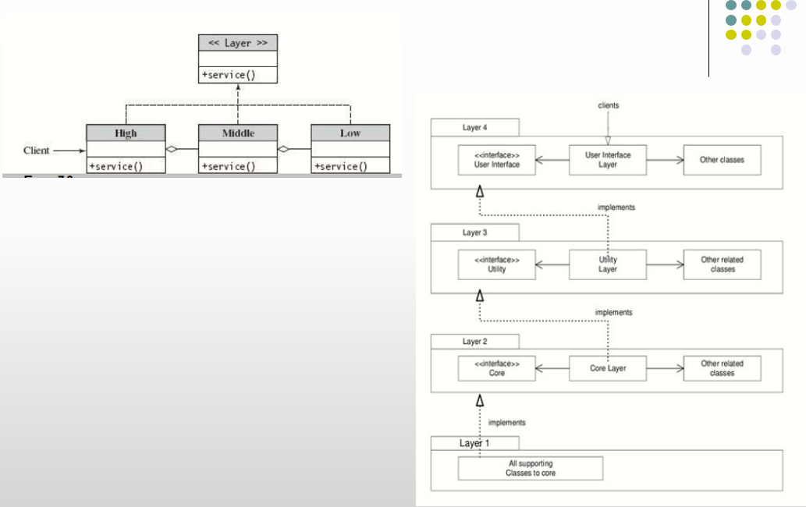

Layered Architecture
Where it’s used:
- Software that needs separate layers for processing and security.
- Data-driven software like CRUD (Create, Read, Update, Delete) applications.
Benefits:
- Clear responsibilities: Each layer has a specific job, making updates easier and teams can work separately.
- Easy to implement and test: Layers are separate, so testing and setting up the software is simpler.
- Better security: Security can be added to each layer individually.
Limitations of Layered Architecture
- Security risk: Security can become an issue if bypassing layers is allowed. The Business Layer usually checks data integrity.
- Complex communication: If not designed well, layers may have complicated interactions.
- Lower performance: Data has to pass through all layers, which can make the system slower.
Layered Architecture – Comparison with Other Architectures
- Client-server, layered, and pipe-and-filter all organize software in layers or parts.
- Client-server is like a small layered architecture with 2–3 layers.
- Pipe-and-filter only lets data flow in one direction, while client-server and layered allow data to flow both ways.

Lecture 9
Implicit Asynchronous Communication Architecture
Implicit Asynchronous Communication Architecture
Overview
This architecture is a way for different parts of a system to communicate without directly calling each other.
The sender and receiver do not wait for each other, so communication happens asynchronously.
Asynchronous Implicit Invocation Communication
- Asynchronous means the sender sends a message and continues his work without waiting.
- Implicit invocation means components are not directly connected.
- Components react automatically when an event or message occurs.
Types of Communication
1. Non-buffered Communication
- Messages are sent directly to receivers.
- If the receiver is not ready, the message may be lost.
- No temporary storage is used.
2. Buffered Communication
- Messages are stored in a buffer (temporary storage).
- Receivers can read messages later.
- This is more reliable than non-buffered communication.

Publisher–Subscriber (Producer–Consumer) Model
- The publisher (producer) sends events or messages.
- The subscribers (consumers) are interested in those events.
How it works:
- Subscription: Components (subscribers) register for events.
Example: “Notify me when a new message arrives.”
- Event Occurs: An event source generates an event.
Example: Button click or new data.
- Event Published: Event is sent to an event space; source doesn’t call components directly.
- Automatic Notification: System notifies all registered subscribers automatically.
- Event Handler Executes: Each subscriber’s predefined function runs to handle the event.
Example actions: Update UI, save data, send notification.
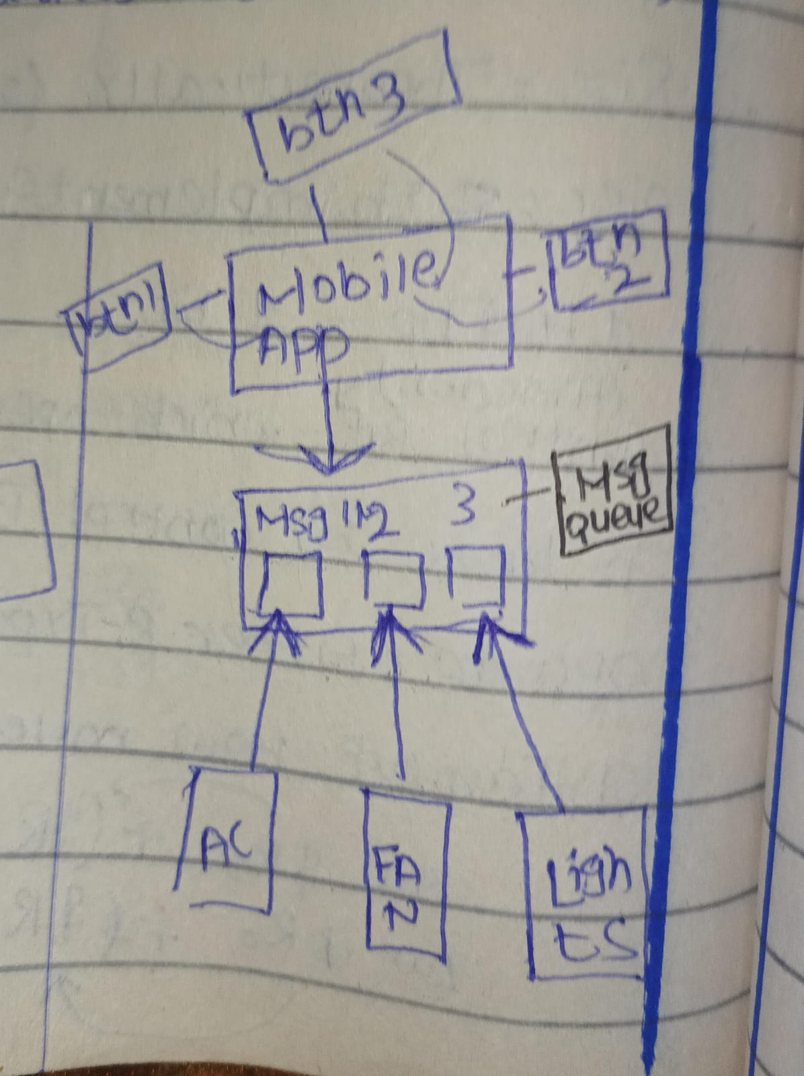

Implicit Asynchronous Communication Architecture
Publisher–Subscriber (Producer–Consumer)
Buffered asynchronous systems use a message queue or topic to store messages temporarily.
Subscribers must register their interest to get messages.
When a message is available in the queue or topic, it is sent to the subscribers automatically.
Types:
1. Message Queue
- Works one-to-one (point-to-point).
- Each message is delivered to only one receiver.
2. Message Topic
- Works one-to-many.
- Each message is delivered to all subscribers interested in that topic.
Non-Buffered Event-Based Implicit Invocations
The system is divided into two parts:
- Event sources – parts that generate events.
- Event listeners – parts that react to events.
Event registration connects the event sources and listeners.
There is no buffer in between, so events are delivered directly and immediately.
In short:
- Event happens → Listeners are notified right away.
- If a listener is not ready, the event might be missed.
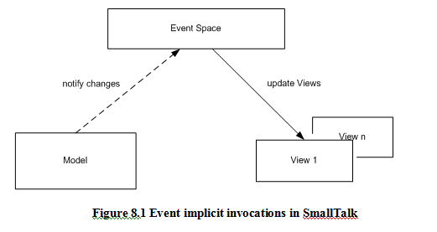
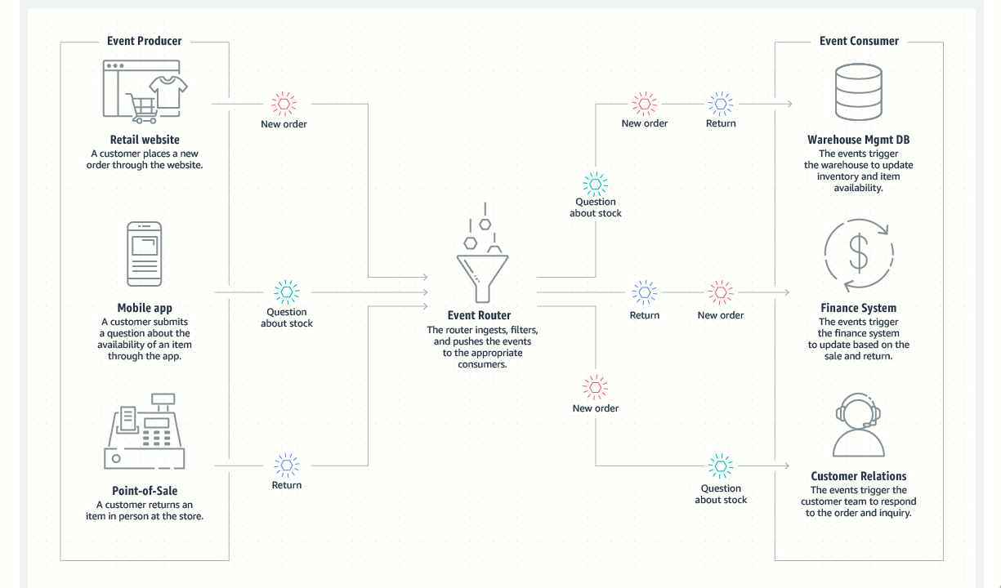
Benefits of Non-Buffered Event-Based Implicit Invocations
- Availability: Events are delivered immediately when they occur.
- Reusability: You can add new event handlers without changing other parts of the system.
- Maintenance and Evolution: It’s easy to update event sources or listeners independently.
- Flexibility: Components can register or unregister for events at run-time.
- Parallel Execution: Multiple event handlers can run at the same time, improving performance.

Buffered Message-Based Software Architecture
The system has three parts:
- Message Producers – parts that create/send messages.
- Message Consumers – parts that receive/process messages.
- Message Service Providers – parts that manage message delivery between producers and consumers.
They are connected asynchronously using:
- Message Queue – for one-to-one communication.
- Message Topic – for one-to-many communication.
This architecture is also called data-centric, because the messages (data) are central to communication.
Buffered Message-Based Software Architecture
What is a Message?
A message is a structured piece of data.
It usually has:
- ID – a unique identifier
- Header – information about the message
- Properties – extra details
- Body – the main content
Example: An XML document can be a message.
What is Messaging?
- Messaging is a system or technology that sends and receives messages reliably.
- Messages can be sent synchronously (wait for response) or asynchronously (no waiting).
How it works:
- A messaging client can send messages to others and receive messages.
- The client must register with a messaging destination (like a queue or topic).
- The message service provider manages a connection session for the client to, create messages, send messages, receive message and read, validate, and process messages
Point-to-Point Messaging (P2P)
- P2P messaging has message queues, senders, and receivers.
- Each message is sent to a specific queue for a consumer.
- The queue stores messages until they are either consumed or expired.
- Each message has only one consumer – once delivered, the message is removed.
- Multiple receivers can exist, but only one receiver gets each message (because queue lock that message that is requested by the specific receiver).
- Every message in the queue must be processed by a consumer.
Example
- In WhatsApp private chat, your message goes to a server queue for the specific recipient.
- If the recipient is offline, the message is stored until delivered.
- Only the intended recipient gets the message; once delivered, it is removed from the queue.
- The server locks the message while delivering to ensure no one else receives it.
- Every message is processed and delivered reliably.
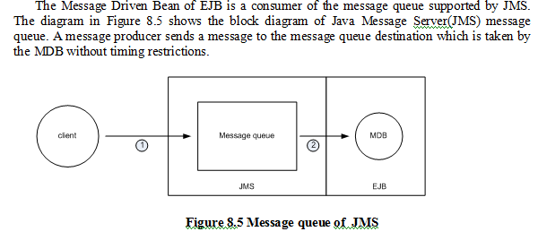
Publish–Subscribe (P&S) Messaging
- P&S has a hub-like structure: publishers send messages to a message topic, which works like a bulletin board.
- Publishers and subscribers do not know each other.
- Unlike P2P (one-to-one), each message can go to multiple subscribers.
- The system delivers messages to all subscribers instead of just one receiver.
- Subscribers must subscribe to a topic before messages are published to receive them.
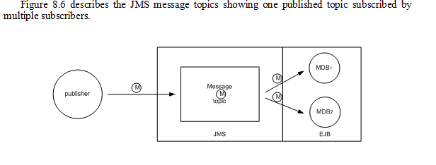
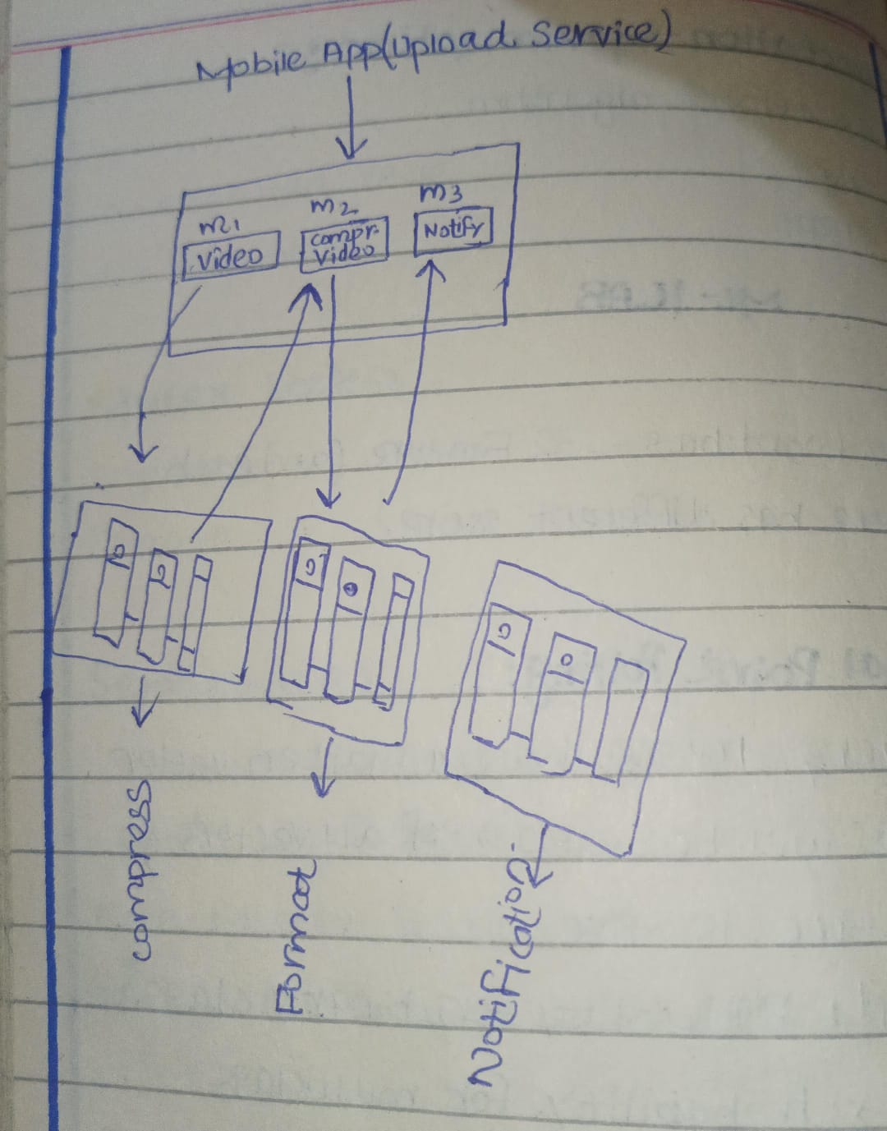

Buffered Message-Based Software Architecture
Applications / Use Cases
- Useful for systems where messages are stored temporarily (buffered) and communication is asynchronous.
- The system is designed so components don’t need to know details about each other, making them easy to replace.
- The application can run even if some components are offline or not running at the same time.
- A component can send a message and continue working without waiting for a response.
Real life example
WhatsApp Example (Buffered Messaging)
1. Sending Messages Asynchronously:
- When you send a message while your friend is offline, WhatsApp stores it on the server (buffer).
- You don’t have to wait for your friend to be online—you can continue using the app.
2. Independent Components:
- Your phone (sender) and your friend’s phone (receiver) don’t need to be connected at the same time.
- The server handles delivering messages when the receiver comes online.
3. Easy Replacement / Scalability:
- WhatsApp servers or components can be updated or replaced without stopping the whole system
Buffered Message-Based Software Architecture
Benefits
1. Anonymity Between Producer and Consumer
- The consumer doesn’t know who sent the message.
- They don’t know where the producer is or when the message was created.
- This provides user, location, and time independence.
2. Concurrency Support
- Multiple consumers can process messages at the same time.
- The producer can continue sending messages while consumers are processing previous ones.
Buffered Message-Based Software Architecture
Limitations
1. Queue Size Limit
The message queue can hold only so many messages.
You can make it bigger with dynamic structures, but memory is still limited.
2. Hard to Manage Agents
- It’s difficult to know how many senders or receivers are needed.
3. Harder to Develop
- Each agent has its own control for communication.
- Keeping things separate makes the system more complicated to build.

4. Overall Complexity
- The system is more complex than simpler designs.

Lecture 10
Interaction Oriented Software Architecture
Interaction-Oriented Software Architecture
Main idea
This type of software architecture separates user interaction from data and processing logic.
This makes the system easier to understand, change, and maintain.
Main Parts of Interaction-Oriented Architecture
The system is divided into three main modules:
1. Data Module
- Stores and manages the data
- Provides data abstraction (hides how data is actually stored)
- Handles databases and data-related operations
2. View (Presentation) Module
- Shows data to the user in a readable format
- Handles user input (like forms, buttons, clicks)
- Different views can exist (for example: web page, mobile screen, reports)
3. Control Module
Acts as the middleman between data and view
Controls the flow of the system
Decides:
- Which view to show
- How modules communicate
- When tasks should run
- Initial system setup and configuration
Multiple View Presentations
The same data can be shown in different formats
Example:
- Desktop interface
- Mobile app interface
- Printed report
All views use the same data module
Why This Architecture Is Useful
- Easy to modify user interface without changing data
- Easy to reuse data and logic
- System becomes clean, organized, and flexible
Interaction-Oriented Software Architecture
MVC and PAC
There are two major styles of interaction-oriented software architecture:
- Model–View–Controller (MVC)
- Presentation–Abstraction–Control (PAC).
Both MVC and PAC are commonly used in interactive applications where there are many user interactions and continuous communication between the user and the system. However, they differ in how they are organized and how the control flow works.
Model–View–Controller (MVC)
MVC divides the system into three connected parts:
- Model: The Model manages data and business logic
- View: The View displays data to the user
- Controller: The Controller handles user input and decides what actions to take.
In MVC, there is no clear hierarchical structure. All three modules are closely connected and work together, making MVC simple and widely used in web and desktop applications.
Presentation–Abstraction–Control (PAC)
PAC also separates the system into three parts, but it follows a hierarchical, agent-based structure. Each agent has its own Presentation (user interface), Abstraction (data and logic), and Control (coordination). The Control component manages communication between agents. Because of this hierarchy, PAC is more suitable for complex systems with multiple interacting components and views.
Key Difference
- MVC: No clear hierarchy; all modules are directly connected
- PAC: Hierarchical and agent-based structure
- MVC: Simpler and commonly used
- PAC: Better for complex and large interactive systems
Model–View–Controller (MVC)
In MVC, different objects have different responsibilities. Some objects handle the main data and logic of the application (Model), some objects handle showing information on the screen (View), and some objects handle user actions and input (Controller). This separation makes the application easier to understand and manage.
Models:
The model represents the core data and rules of the application. It stores information and performs the main processing related to the application domain.
Views:
Views handle everything related to display. They ask the model for data and show that data to the user in a graphical form.
Controllers:
Controllers manage user input. They take input from devices like the keyboard, mouse, or time events, and decide how the model and view should respond.
MVC-I
MVC-I is a simpler form of MVC architecture. In this style, the system is divided into only two main parts instead of three:
1. Controller-View
- Handles user input (keyboard, mouse, clicks)
- Shows output to the user
- Manages the input and output interface
2. Model
- Contains all the main logic of the application
- Manages data and core functionality
How It Works
- The Controller-View is connected to the Model
- It registers (attaches) to the Model to get updated data
- When data changes, the Model informs the Controller-View
MVC-I
- The Model module informs the Controller-View module whenever the data changes.
- Because of this notification, the display on the screen is updated automatically to show the new data.
- The controller also responds properly to these data changes (for example, refreshing the screen or enabling buttons).
- The connection between the Model and Controller-View follows a subscribe–notify pattern.
- This means the Controller-View subscribes to the Model, and the Model notifies it whenever something changes.
- In simple words, the Controller-View acts as an observer that watches the data inside the Model.
Analogy:
Think of a weather app:
- The app subscribes to a weather service (Model).
- When the temperature changes, the service notifies the app.
- The app automatically updates the screen to show the new temperature—no need to be refreshed manually.
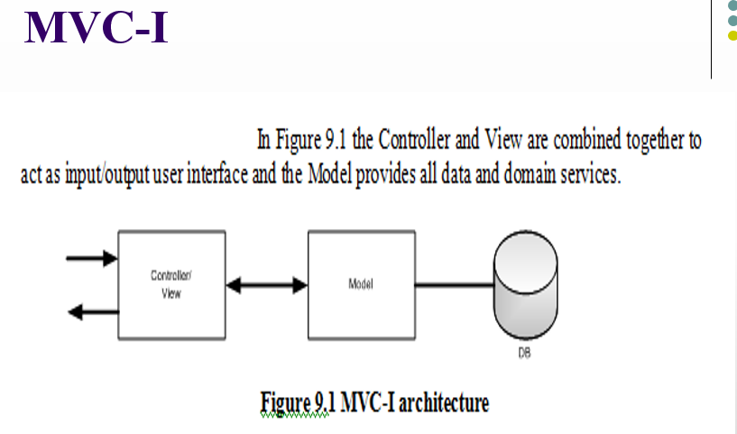
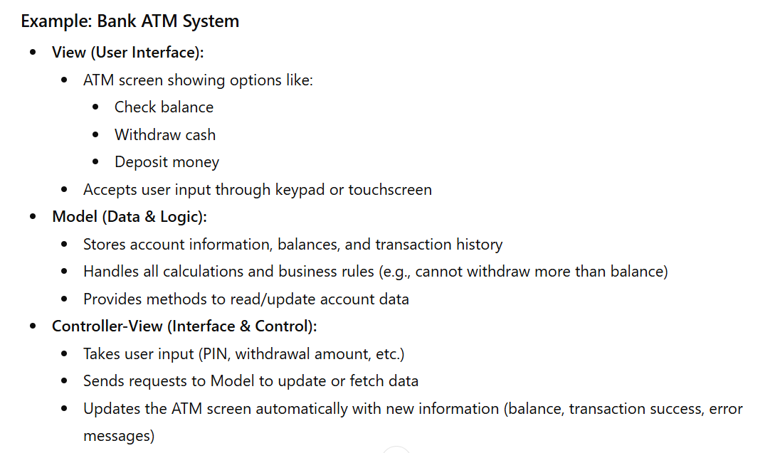

MVC-I
- Whenever the data in the Model is updated it will notify the registered GUI components of changes, and then the GUI components will update their displays.
- This is why we say that the data in the Model of MVC architecture is active rather than passive.
Active Model = its “pushes” updates to the View
Passive Model = it “sits quietly” until asked
MVC-II Architecture
Overview:
MVC-II is an improved version of the earlier MVC-I architecture. Like MVC-I, the Model module plays an active role, notifying other modules whenever data changes. However, MVC-II introduces a clearer separation between the View and Controller modules, improving modularity and maintainability.
Model Module:
The Model handles all core functionality and data, often supported by a database. It actively notifies the View and Controller whenever there are changes in the data, ensuring that the display and system behavior stay up-to-date automatically.
View Module:
The View is responsible for displaying data to the user. It updates its interface whenever the Model changes, keeping the user interface in sync with the underlying data.
Controller Module:
The Controller handles user input, validates it, initiates connections between the Model and View, and dispatches tasks. It ensures that the user’s actions are correctly processed and reflected in the system.
Advantages of Separation:
In MVC-II, the View and Controller are separate, which allows division of labor: programming experts can focus on the Controller, while UI/graphics experts work on the View. This separation is especially useful because graphics technology changes rapidly and business requirements evolve often, making it easier to maintain and update the system.
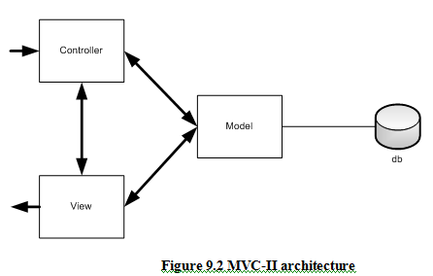
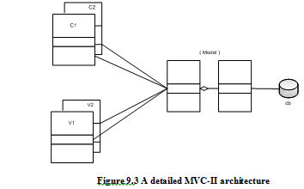
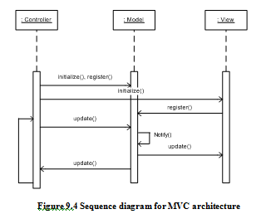
MVC-II Architecture
How MVC Works
Initialization:
When the application starts, the Controller sets up both the Model and the View. It also registers the View and itself with the Model, so the Model knows who to notify when data changes.
Handling User Requests:
Later, when the user interacts with the system—either through the View interface or directly from a command line—the Controller intercepts the request and sends it to the Model to update the data.
Automatic Updates:
Whenever the Model’s data changes, it notifies all registered listeners (the View and Controller). As a result, the View updates immediately, so the user sees the latest information without any extra steps.
MVC
Applications
Interactive Applications:
- Works well for systems where one set of data needs to be shown in different ways (multiple views).
- Useful when the user interface changes often, because updates in the data automatically appear in all views.
Team-Based Development:
Best for systems where Controller, View, and Model are clearly separated.
Allows different people to work on different parts at the same time:
- Programmers focus on the Controller
- Designers focus on the View
- Data experts focus on the Model
MVC
Benefits
Availability of Tools:
Many MVC frameworks and toolkits are available to help developers build applications easily.
Multiple Views:
The same data model can be shown in different views at the same time, all synchronized automatically.
Flexible Interfaces:
It is easy to add new views or change existing ones without affecting the data or business logic.
Team Development:
Very effective when a team of experts is working together:
- Graphics/UI designers work on the View
- Programmers work on the Controller
- Database professionals work on the Model
Limitations
Expensive Updates:
If a data model changes, all connected Controllers and Views may need updates, making changes time-consuming and costly.
Unclear Separation:
Sometimes, the boundary between the View and the Controller is not very clear, which can make the design confusing.

